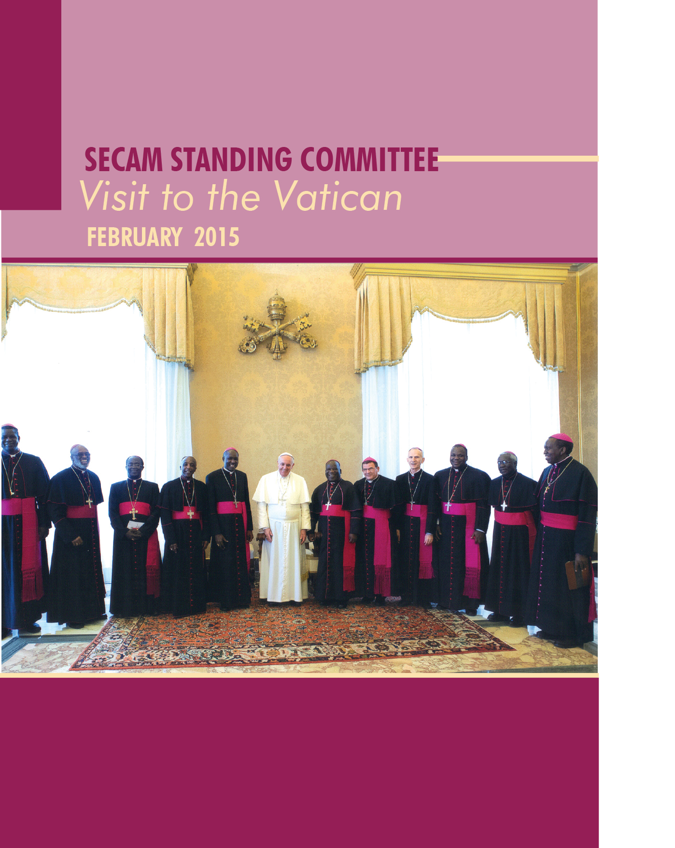

Introduction
In early 2013, SECAM decided to undertake a pilgrimage to the Vatican. It also saw it as an opportunity to hold official meetings with some of the Dicastries (Ministries) of the Vatican and to climax it with an audience with the Holy Father, Pope Francis. Having received the green light from the Vatican through the Apostolic Nuncio to Ghana, Archbishop Jean-Marie Speich, the visit took place from February 2 to 8, 2015. The delegation which comprised 11 bishops of the Standing Committee of SECAM and five Staff members and two Consultants of the Secretariat was led by Archbishop Gabriel Mbilingi,CssP,President of SECAM. This is the first time that a delegation of SECAM has paid an official visit/pilgrimage to the Vatican.
The delegation held discussions with heads of a number of some major offices of the Vatican. The offices included the Secretariat of State; the Congregation for the Evangelisation of Peoples; the Secretariat of the Synod of Bishops and the Pontifical Council for Justice and Peace. The rest are, the Pontifical Councils for Culture; Inter-religious Dialogue; and that of the Family.
The bioshops were at the Vatican to share with the Holy Father and his immediate collaborators heading dicasteris some of the programmes and projects which they are carrying out through their Secretariat in Accra, Ghana.
It was also for them , to express their communion with the Universal Church and as a pilgrimage to visit the tombs of Saints Peter and Paul and to renew their faith and pastoral vows.
( see list of the delegation on appendix A).
Preliminary meetings:
- Meeting with Cardinals from Africa at the Vatican.
On the day of arrival ( February 2), the Standing Committee held a meeting with Cardinals and Bishops who are resident/working at the Vatican who were led by His Eminence, Francis Cardinal Arinze. ( the other members were Cardinals Robert Sarah and Peter Turkson and Archbishop Bathelmy Adoukuno. The discussions were basically on how to improve the evangelization efforts of the Catholic Churh in Africa.
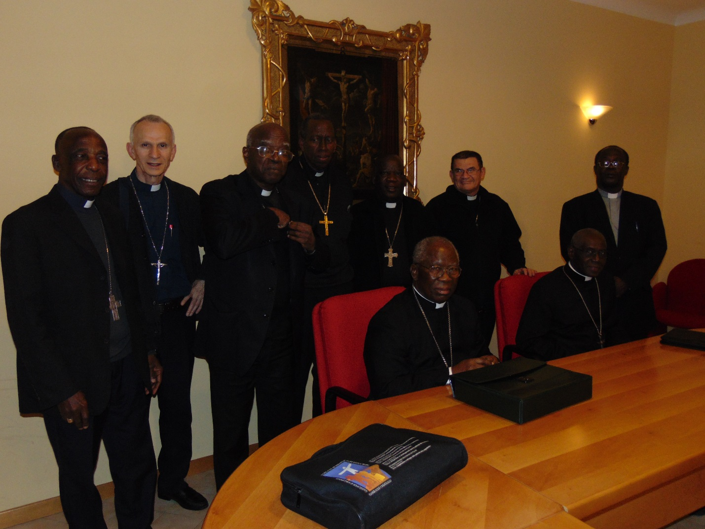
ii) Meeting with the Africans in the diaspora -in Europe.
This was followed by a meeting between Bishops of SECAM and Africans in the diaspora in Europe. The Africans in diapsopra informed them about their activities in Italy and other parts of Europe. They appealed to SECAM to give them whatever support in addressing the numerous challenges that they are facing as students or workers in Europe.
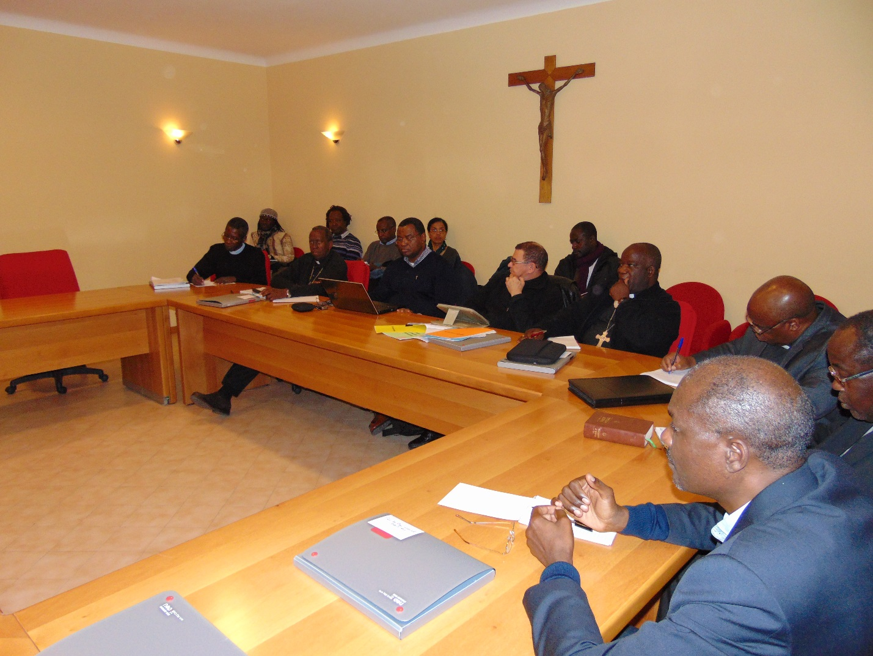
Archbishp Mbiling, President of SECAM, at head of the table (right), listening to Africans in the diaspora. With them are some members of the Standing Committee of SECAM
Meetings with the Dicasteries.
- Pontifical Council for Culture:
In the morning of February 3, the SECAM delegation held its first meeting with the Pontifical Council for Culture (PCC). The PCC side was led by His Eminence, Gianfranco Cardinal Ravasi, President. Present were Mons. Barthelemy Adoukonou, Secretary of the Council and Mr. Richard Rouse of the Communications Department of the Council.
During the meeting the President of SECAM, Archbishop Gabriel Mbilingi presented the following message:
Your Eminence, on behalf of my brother bishops here present and of the entire Church in Africa to convey to you our sincere gratitude and thanks for having accepted to welcome us to the Pontifical Council for Culture of which you are the President.
We are here to share with you some of the programmes and projects which we are implementing at our Secretariat in Accra, Ghana.
We wish, first of all, to express out communion with the Universal Church. It is also a pilgrimage for us to visit the tombs of St. Peter and Paul, a trip which renews our faith and our pastoral vows.
As your Eminence is aware, SECAM has, in collaboration with your Council, established a Faith, Culture and Development Commission which, among other things, is aiming to promote the integral human development on the African continent and to deepen our cultural values through our faith.
To this end, last April, SECAM availed itself to the canonisation of Popes John XXIII and John-Paul II, to highlight the contribution of both Popes and the implementation of the outcomes of the Vaticn II Council on the African continent by organising here in Rome a symposium on the theme "the Church in Africa: From the Vatican Council II to the third Millennium – Tribute from Africa to Pope John XXIII and Saint John-Paul II »
Eminence, the Church in Africa is committed to playing a greater role in the construction of a new cultural identity for the continent, and in particular, through the programmes and projects of this Faith, Culture and Development Commission.
Our most fervent wish is that our African cultures become more rooted in the christian faith and that they become recognized in the comity of world cultures.
Eminence, We wish to continue to count on the co-operation and collaboration of your august Council.
Cardinal Ravasi on part also made reference to the homage paid by Africa to Popes John XXIII and John Paul II during a Conference held in Rome 24-25 April 2014 and the encouragement that his Council is giving to the Faith, Culture and Development Forum of SECAM.
AfricCa, he said is has lively peoples who are fond of dance, music and very spontaneous cultural expressions. He also noted that the continent is opening up to globalizing tendencies amidst its traditional challenges of poverty and injustices.
Cardinal Ravasi made reference to Culture e Fede Vol. XVII 2010 N. 4 Theme: Africa and Culture a publication of the Council which specifically discusses development in Africa, practices that are destructive to the African ecosystem, and the wider societal implications that result. Another pertinent topic is the introduction of technological and scientific advances in Africa. He appealed to the Church in Africa to pay more attention to the education of the youth who are being affectesd by the negative side of the internet. “ it is a pastoral duty.” he stressed.
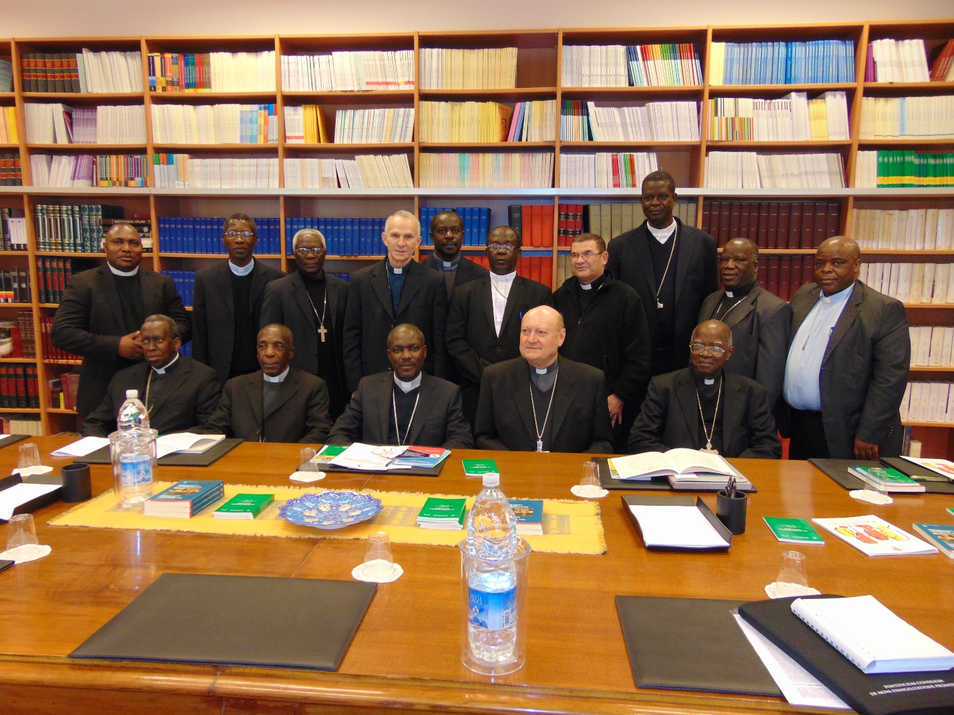
SECAM Delegation at the Pontifical Council for Culture. For some information on the PCC Please see Appendix…..)
- Pontifical Council for Inter-religious Dialogue
The second meeting of the delegation was with the President of Pontifical Council for Inter-religious Dialogue, His Eminence Jean-Louis Cardinal Tauran, President of the Pontifical Council for Interreligious Dialogue soon after the meeting with the Pontifical Council for Culture.
The President of SECAM in his presentation, acknowledged that several African countries have always experienced a peaceful coexistence among the various religious groups. Unfortunately increasingly, however, many acts of violence and conflict have been rearing their ugly heads under the cover of religion on our continent.
It was for this reason, he expalined that ‘our Justice and Peace Commission, in collaboration with the African Council of Religious Leaders for Peace, the Council of African Churches and the Organisation of African Unity of Churches initiated an African Religious Leaders’ Programme on Inter-Faith Dialogue aimed at bringing peace, reconciliation and development.
The Catholic Church in Africa, he stressed is making efforts to promote inter-faith dialogue so as to forestall any possible religious conflict which could engulf the entire continent. We therefore look forward with interest to cooperating with your Council in the Promotion of Inter-Faith Dialogue aimed at a peaceful coexistence in all parts of Africa.
We could envisage joint initiatives with the leaders of the major religious bodies so as to adopt concrete measures to respond to the threat of religious extremism or religious intolerance.
A member of the Standing Committee, Archbishop Paul Desfarges, of Constantine in Algeria, gave an overview of the challanges and the efforts of the Church in the realm of inter-faith dialogue in North Africa which is predominately Muslim.
Cardinal Turan who described himself as “ an Ambassador of Africa” urged Africa to sell the positive aspects of their culture, education and hdigh level of faith. He noted that African is squeezed between the influence of China and Islam and other challenges for which that the continent has to wake up. The Church in Africa should never be afraid to speak the truth.
The Cardinal gave a brief presentation of his Council as a dicastery of the Roman Curia, erected by Pope Paul VI on 19th May, 1964 as the Secretariat for Non-Christians, and renamed by Pope John Paul II on 28th June, 1988.
Please Appendix .. for some information on the Council.
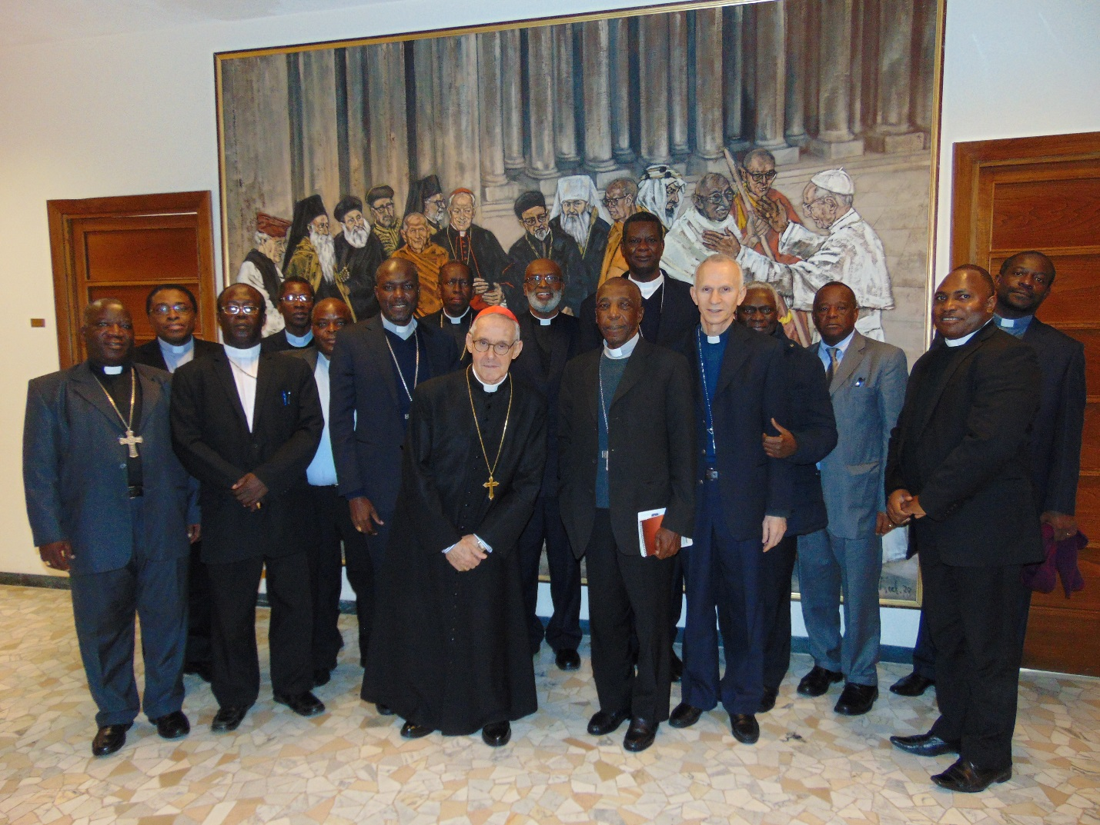
SECAM delegation with Cardinal Turan President of the Pontifical Council for Inter-religious Dialogue.

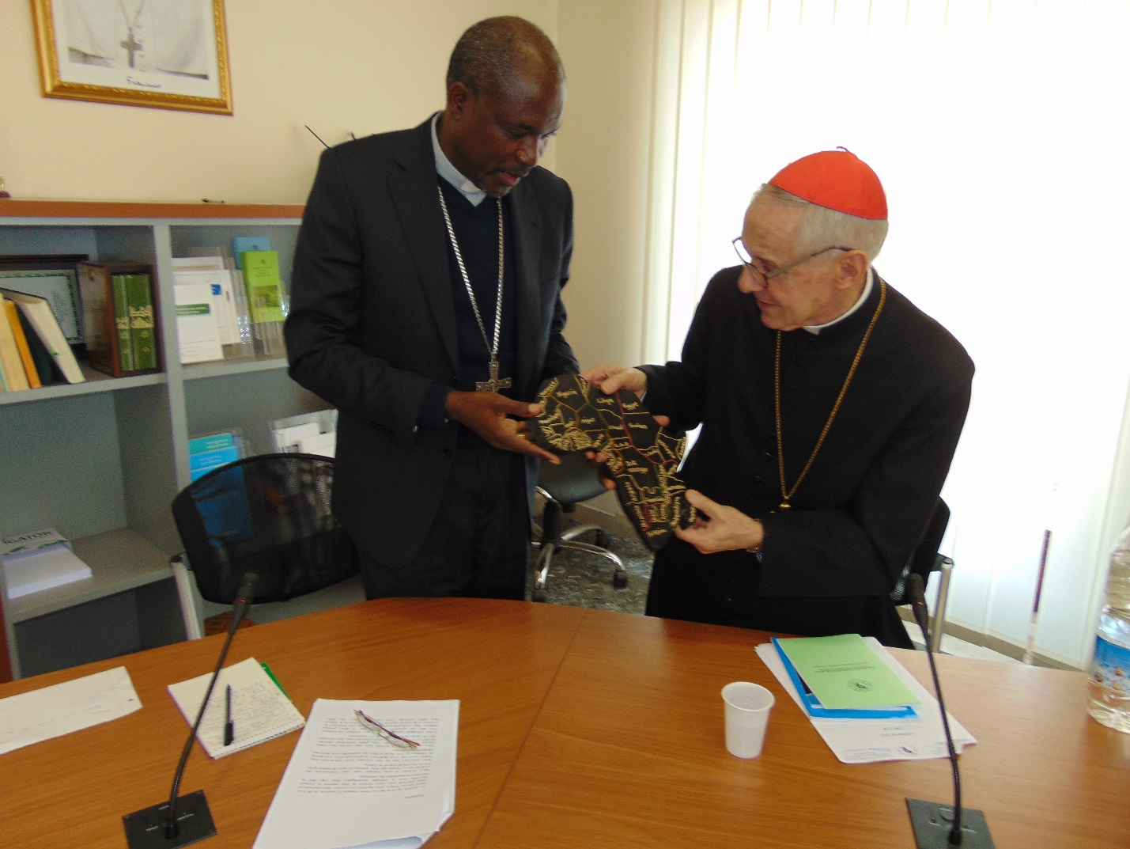
Cardinal Turan admiring a wooden map of Africa from the President of SECAM, Archbishop Mbilingi
- Synod of Bishops
The Standing Committee of SECAM rounded up the day, February 3, 2015 with a meeting at the Secretariat of the Synod of Bishops. They were received by His Eminence Lorenzo Cardinal BALDISSERI, Secretary General of the Synod of Bishops. With him were Mons.. Fabio Fabene, Under Secretary of that Secretariat and another staff member, Mons. Etienne Brocard.
In his speech, the Presidentof SECAM, Archbishop Mbilingi said that Africa was most impressed with the immense work that has been accomplished since the institution of the Secretariat of the Synod for Bishops. According to him ‘’ all our pastoral actions have been inspired by the recommendations addressed both to the Universal Church and to our particular Churches.
He cited the two Synods on Africa and the one of October 2014 on the Family which ‘’inspires us to revisit all the teaching of the Gospel as far back as the time of Evangelisation of our peoples. The challenges facing this divino-human institution call upon us to draw insipration from Christ to better walk with the new Evangelisation.’’
He told Cardinal Baldisseri that SECAM was looking forward with keen interest to working with his Secretariat, with a view to a greater pastoral and ecclesial promotion for the continent of Africa.
Archbhop Mbiling was of the conviction that SECAM as a structure for organic pastoral promotion could make an effective contribution to the next deliberations of the Synod of Bishops on pastoral issued linked to the family at the meeting scheduled for October 2015.
Bishop r. Louis PORTELLA MBUYU, First Vice-President of SECAM, and Bishop of Kinkala, Congo, in a contribution mentioned some of the activities of the ACERAC Region and the controbution of Association of African Theologians regarding the Synod on the Family in 2014. It will be recalled that the Afican Theologians under the auspices of the Evangelisation Commission of SECAM prepared some douments for the bishops of Africa who took part in that Synod.
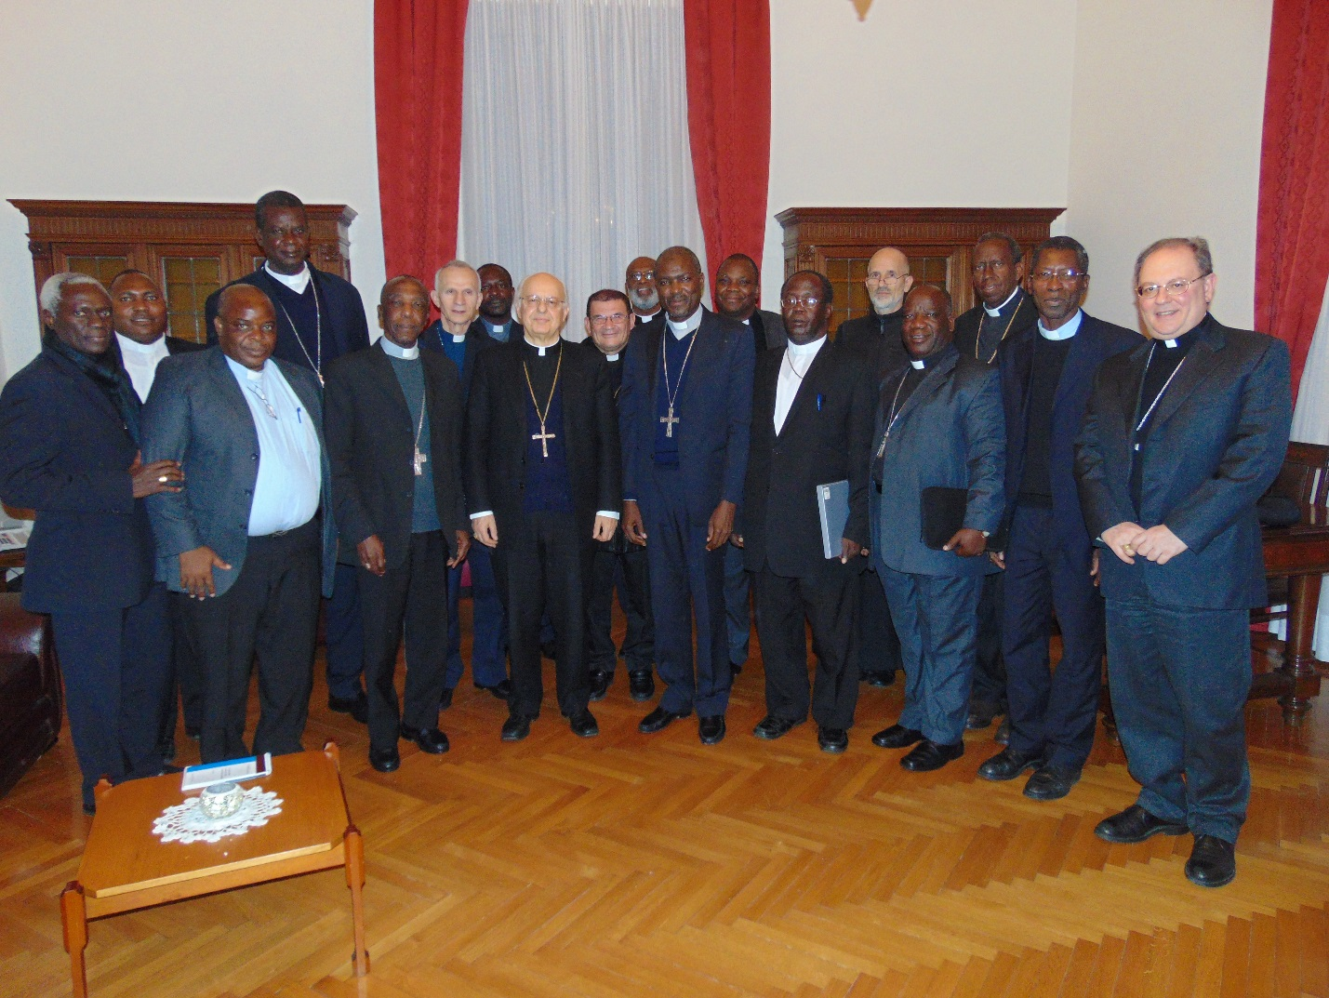
( Cardinal Baldesseri with the SECAM delegation)
In his response, Cardinal Baldisseri briefed the delegtion on the activities of his Secretariat. Referring to the Synod on the Family of October 2014, he said it was divided into three parts : a) Listening to the Holy Spirit regarding Pastoral Challenges of the Family ; b) Theological reflection and c) Doctirne versus Reality- Perspecttives.
He noted that the interest showned througout the world reegarding the Synod was overwhelming. He expressed his dispointment in the way the proceedings of the Synod was presetned by the media. The Cardinal was, however very happy that Pope Francis gave a very beautiful summary of all that took place during the Synod on the Family.
On a reguest for official representation of SECAM in the participation of future Synod, the Secretary General of the Synod of Bishops told the bishops that that was a matter that only the Holy Father could address.He explained that the present Statutes of the Secretariat does not take into consideration Continental Conferences but only National Episcopal Conferences.
Caldinal Baldisseri informd the delegation that this year- 2015 marks the Golden Jubilee of the founding of the Synod of Bishops.
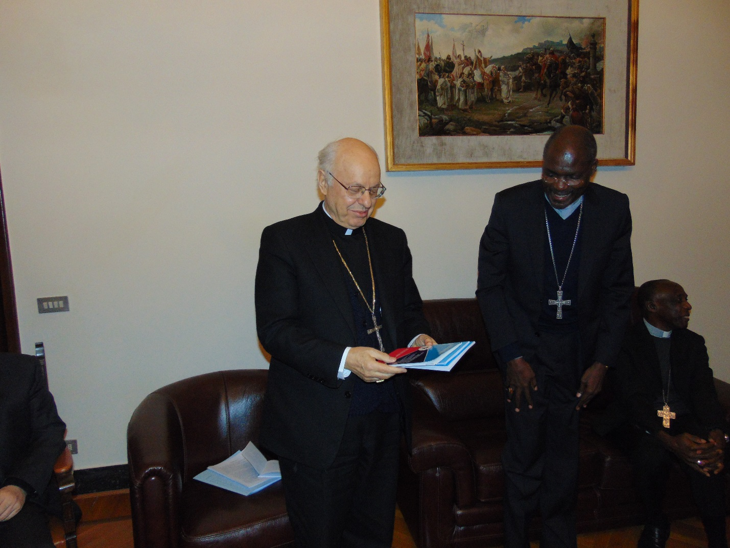
(Cardinal Baldesseri holding some recent publications of SECAM he received from Arcbhishop Mbilingi)
Please refer to appendix… for some information on the Synod of Bisshops.
- Congregation for the Evangelisation of Peoples
The delgaation of SECAM continued its meetings with the dicaasteries on February 4, 2015 first at the Congregation for the Evangelisation of Peoples. The Bishops met with His Eminence, Fernando Cardinal Filoni, Prefect of that Council. He had with him Archbisshop Savio Hon Tai-Fai (SDB), Secretary of the Congreation; Archbishop Protase Rugambwa, Adjunct Secretary; Mons. Taddeo Wojda and Rev. Fr. Crispin Kinbeni both officials od rhw Congregation.
After exchanging some pleasantries, the President of SECAM expressed the appreciation of SECAM to Caridnal Finoli and his staff for the invaluable work they are doing for the promotion of evangelization in Africa. He appealed to the Congreagation to help SECAM to reach out to all bishops in Africa for them to be more engaged and committed in supporting SECAM ‘as a continental structure for solidarity and Ecclesial Communion’ (Africae Munus 107).
He also thanked the Congregation for the subsidies that they give to SECAM Secretariat from time to time. He however asked for an increase in this subsidy and make it a regular feature. Such a support Archbishop Mbilingi said would be uised among other issues in the capacity building and on-going formation of the priests and lay people of our Secretariat.
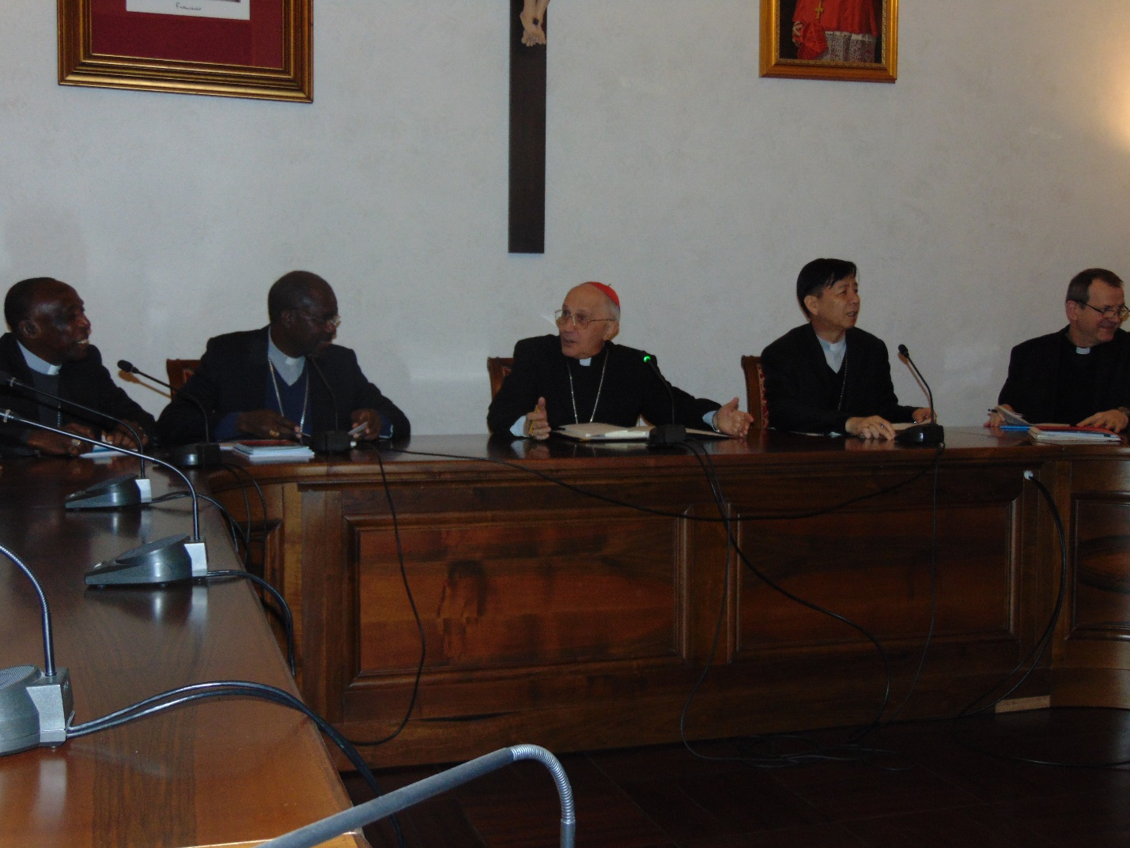
Cardinal Feloni and his staff addressing the SECAM delegation
Cardinal Filoni gave a history of his Congregation with specific reference to what it has been able to achieve in Africa. The Congregation he said would like to give more service to the continent of Africa and therefore the need for the collaboration of each Episcopal Conference to do more for the evangelization and the integral development of the continent. He commended SECAM for having developed a Strategic Plan.
Africae Munus, he pointed out, should be a Carta Magna for the bishops and people of Africa. He also referred to Gadium Spes. These two documetns he said should be used by the Church in Africa particularly in finding solutions to the challenges that are militating against the development of the continent.
He urged Africans to use their resources for education, health and job creation, peace building etc. instead of using them on arms. “ Peace is very necessary for the development of Africa. The solution to the challenges facing Africa is the hands of Africans, you have all the resources to develop instead of depending on others.” he stressed.
The Cardinal exhorted the Church in African to do away with tribalism which he described as a sickness in some part of the Church on the continent. “ Translate your Church in Africa as Family into reality- action and not just by word. He added.
A number of the bishops made contributions on what what the the Church in Africa is doing to address of the negative tendercies that are keeping the continent from developing faster than it is doing presently.
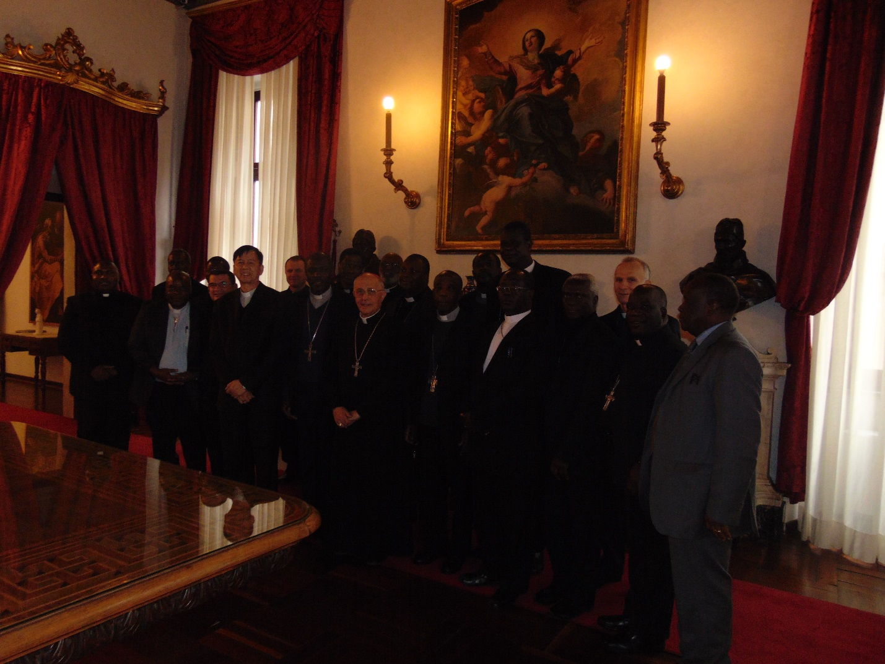
SECAM delegation with cardinal Feloni and his staff
- Pontifical Council for Justice and Peace
The delagation of SECAM on February 5, moved to the office of the Pontifical Council for Justice and Peace at Piazza san Calisto, Rome where they we received by the President of that Council, His Eminence Peter Cardinal Turkson.
Archbishop Mbilingi, head of the deleagtion informed the Council that the Justice, Peace and Development Commision of SECAM through its programmes and projects contribute towards the achievement of SECAM’s mission in the promotion of unity, and collaboration with the development organisations and bodies for Africa.
The Commission he erxplained aims to respond to the challenges that Africa is facing, with special emphasis on the problems of good governance, justice, peace and development. ‘’Through the liaison of the Catholic Parliamentary Liaison Office of the local Churches, National Conferences and regional structures, the Justice Peace and Development Commission is poised to handle political and socio-economic developmental issues’’
Thanks to the Commission, Archbishop Mbilingi pointed out, some regional and national Episcopal Conferences have started participating in policy development with special reference to the needs of the very poor and the most marginalized. He also informed the Council that a handbook on HIV and AIDS has been developed and is being used for the training of trainers.
He announce that in consonance with one of the recommendations of Africae Munus (nr. 157) SECAM has decided to organise a Year of Reconciliation for the entire African continent.
In a contribution, Most Rev. Gabriel Justice Anokye, Second Vice-President of SECAM and Chairman of the Commission talked about the work that the Commission is currently doing. He took the opportunity to remind and again invite Cardinal Turkson to a Congress of the Commission that was scheduled for March in Namibia. The theme of Congress was: Justice and Peace at the Service of reconcilation and integral development in Africa.
SECAM thanked Cardinal Turkson as well as his staff for the invaluable support to the Commission. ‘’We wish to pursue this collaboration with your Council so as to provide a stronger voice to the Church in the resolution of problems confronting Africa with reference to development at the next UN General Assembly and at the UN Conference on Climate Change.

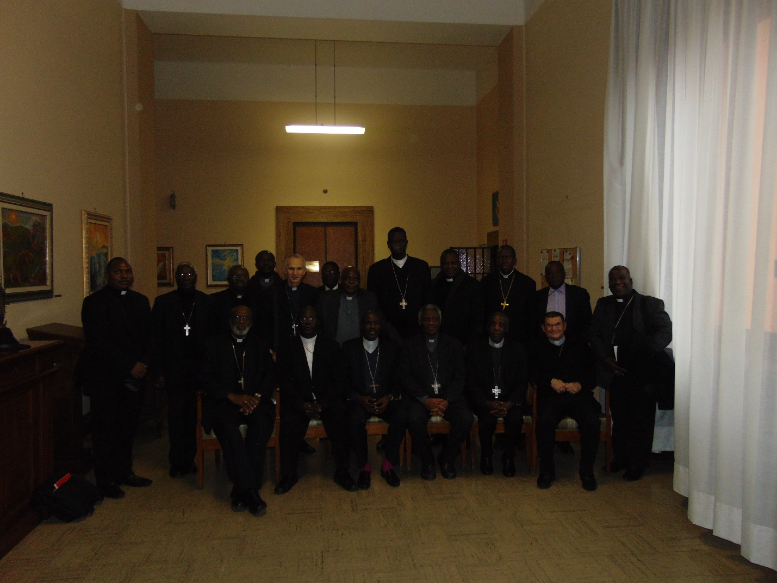
Seated from left to right are : Archbishops Palamer-Buckle, Anokye and Mbilingi ; Cardinal Turkson, Bishop Mbuyu and Archbishop Ramaroson.
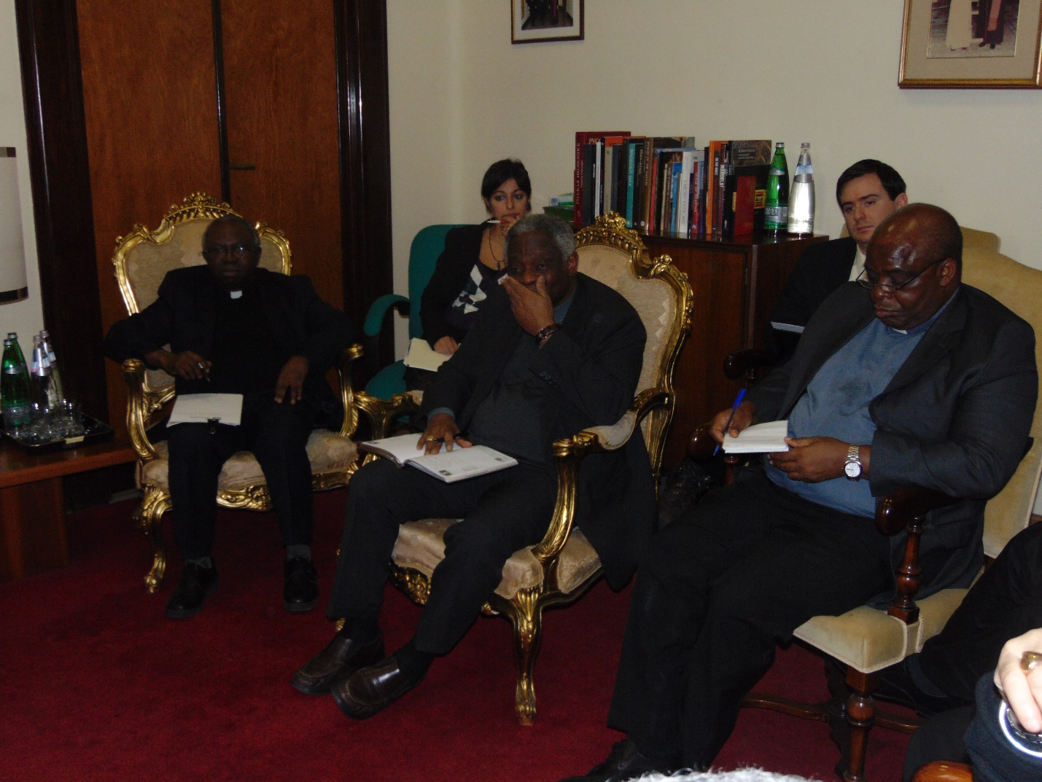
Cardinal Turkson with some of his staff members on the right is Fr. Komakoma, Secretary Genral of SECAM.
In his repsonse, Cardinal Turskon presented the activities of his Council and what it is doing specifically in Africa. He apealed to SECAM to consult his Council when issueing official statemetns on policy issues that have international dimenstion. This,he empahsised is to avoid Church speaking at different directions.
He also urged the Church in Arica to fight the new forms of slavery, the negative effect of mining, and pollution of the environment.
On the invittion to the Congress in Namibia, Cardinaal Turkson said that he would send representation since he would not be available.
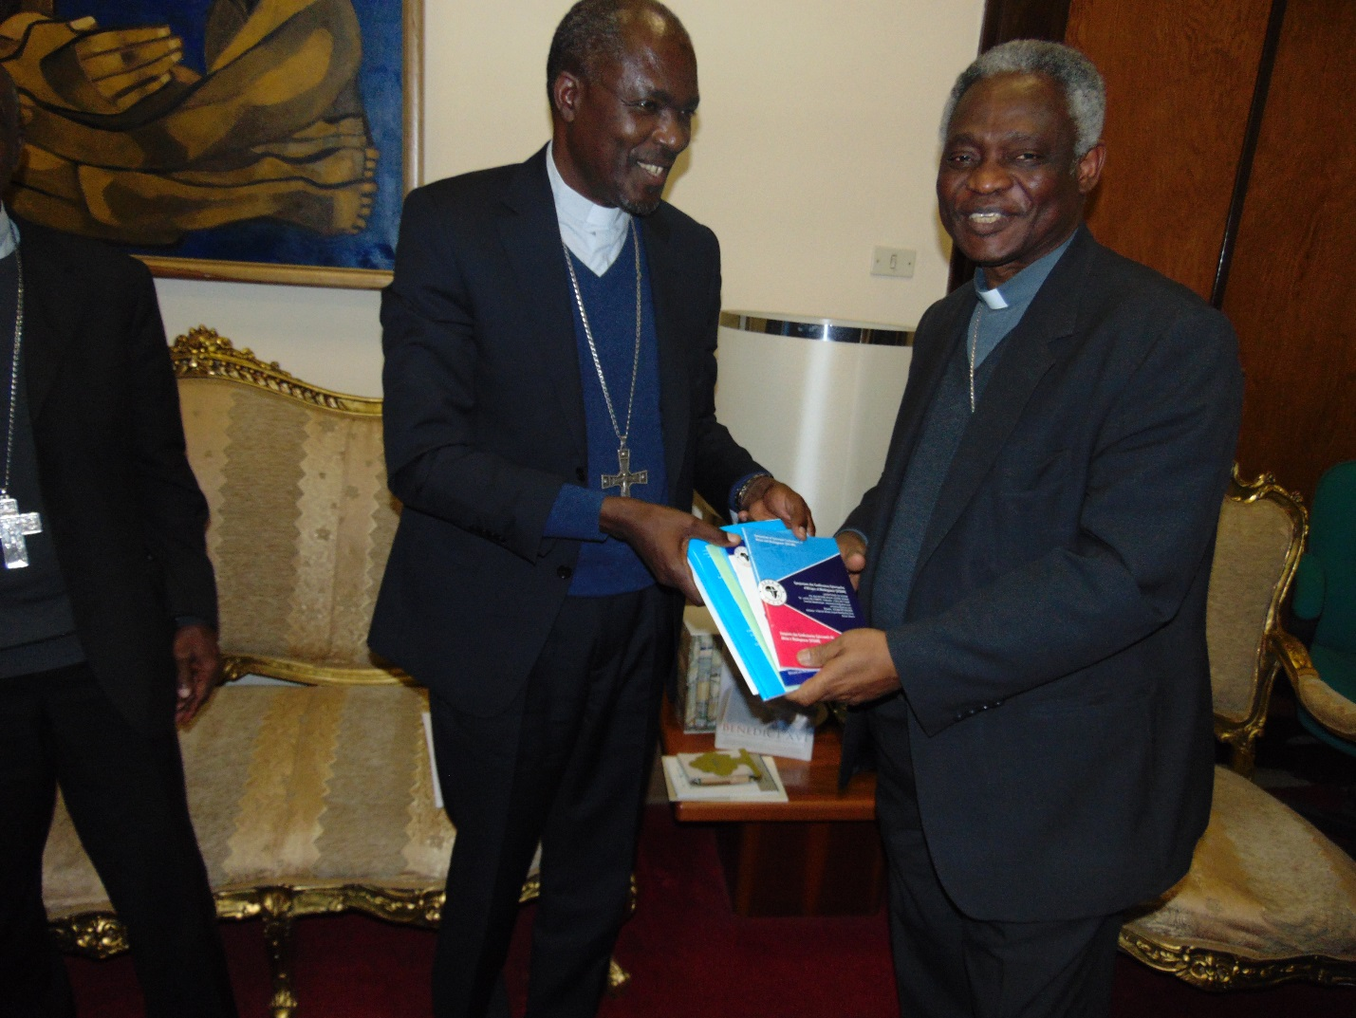
Cardinal Turskon receiving a set of recent publications of SECAM from Archbishop Mbilingi.
- Secretariat of State II( Relations with States)
On February 6, the delegation met with Archbishop Paul Richard GALLAGHER, Secretary of State, in- Charge of Relations with Foreign States at the Palazzo Apostolico at the Vatican.

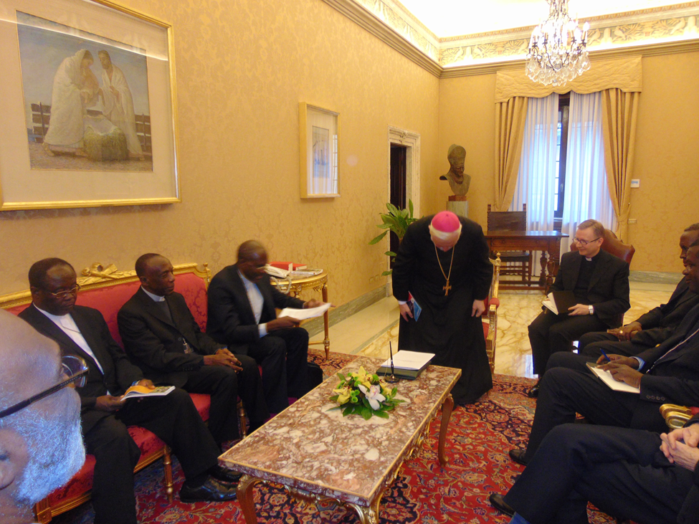
Archbishop Galagher about to take his seat.
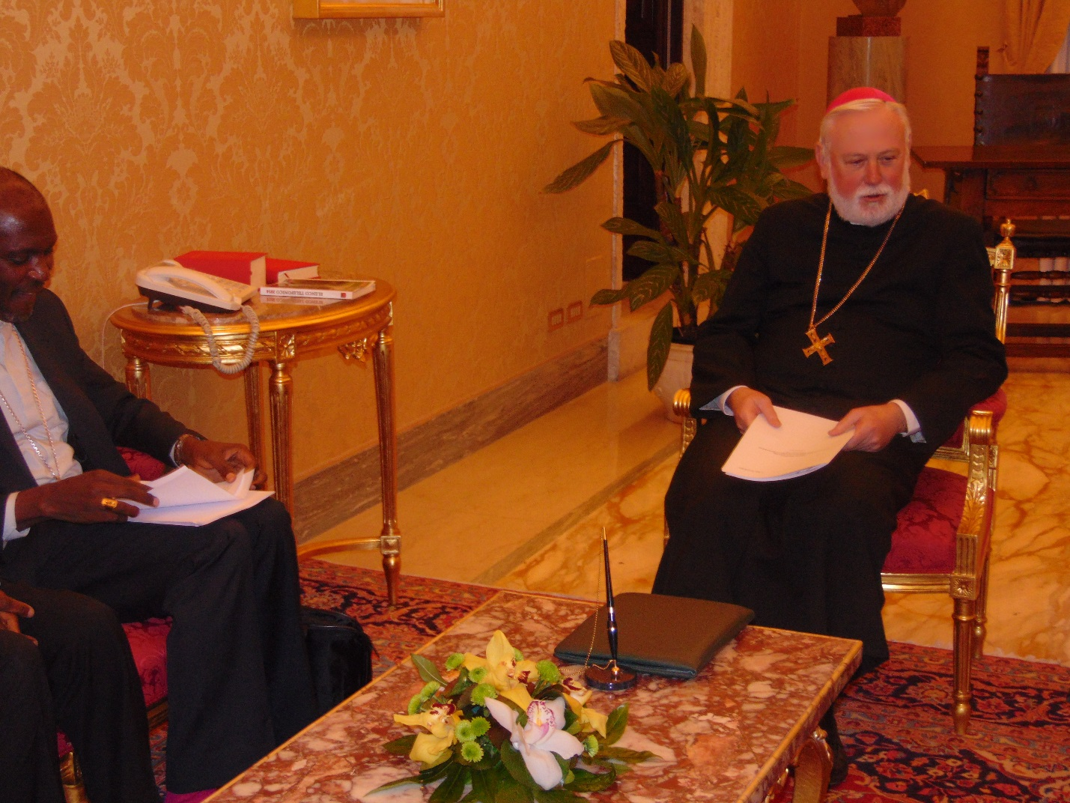
Archbishop Mbilingi presenting his message to Archbishop Gallagher
The President of SECAM commended the Vatican for having established diplomatic relations with several African countries and the many framework agreements that have been developed and signed with the Holy See; agreements which he observed have helped to improve relations between the State and the Church in Africa.
He informed Archbishop Gallagher that SECAM will soon formally sign a Memorandum of Understanding (MOU) for an Observer status with the African Union. He added that in most counties on the African continent the Church has established Catholic Paliamentry Liaison offices.
Archbishop Gallagher in welcomg the bishops presented brief nfomration about the work of his Secretariat.
In commending SECAM for the great work it carrying out Archbishop Gallagher asked the Church to work closely with Governments for the integral development of the people of Africa without compromising the Teaching of the Church.
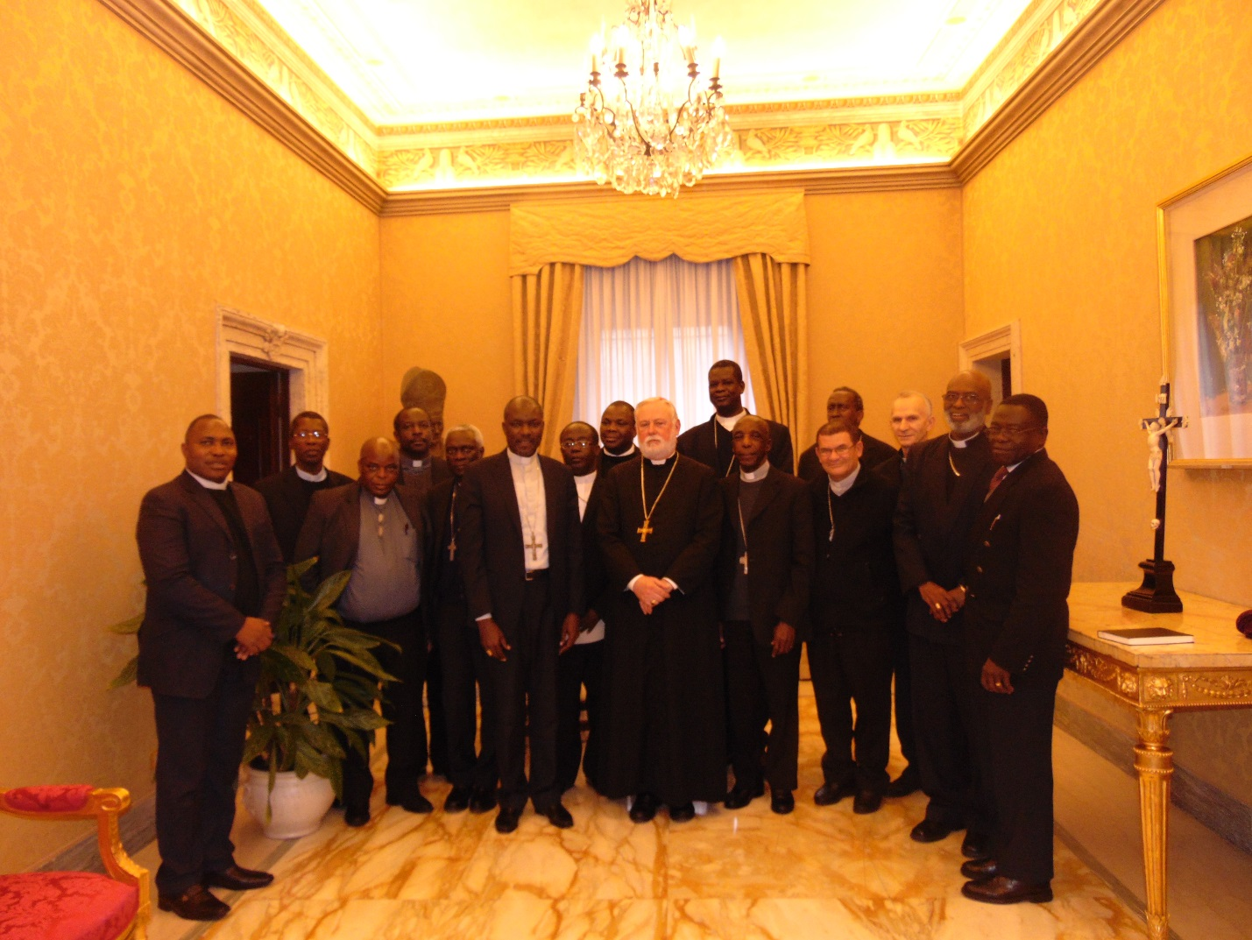
Archbishop Gallagher with the delegation of SECAM
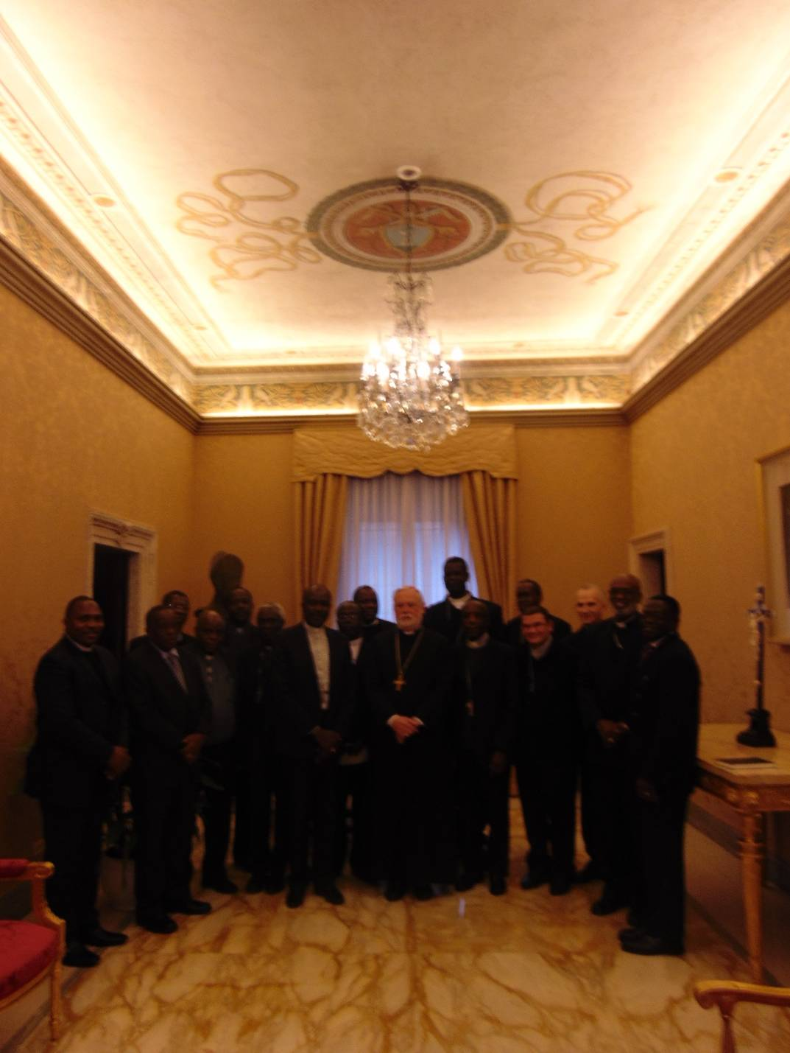
- Audience with the Holy Father
On Saturday, February 7, the delegation was received in audience by the Holy Father, Pope Francis at the Consistory hall at the Apostolic Palace. After each member of the delegation had an opportunity to greet the Pope, the Bishops held a closed door meeting with Pope Francis.
The President of SECAM, Archbishop Mbilingi on behalf of his broher Bishops presented the Pope a message on the current situation of the Catholic Church in Africa.
The Bishops invited the Pope to Africa, this year and in particular to their 19th Plenary Assembly in Uganda in 2019. That Assembly will also mark the Golden Jubilee of the founding of SECAM.
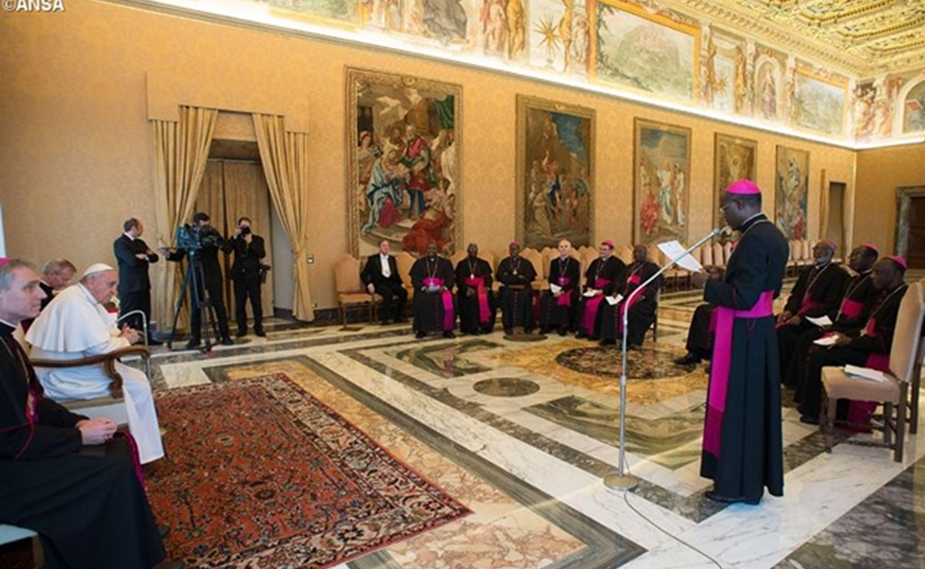
Archbishop Mbilingi addressing the message below to Pope Francis:
Holy Father,
It is a great honor and a great joy for us Bishops, Members of the standing committee of the Symposium of Episcopal Conferences of Africa and Madagascar (SECAM) and our collaborators to be receivedby you today.
Indeed, SECAM’s existence dates back to the appeal made by your venerable and blessed predecessor Pope Paul VI in Kampala, Uganda in 1969, is a pastoral organof the Catholic Church in Africa. SECAM is at the service of the Episcopal Conferences in Africa. It respects their autonomy. It facilitates their task by promoting collaborative study of issues of common interest and common action. "(See Article II of our Constitution).
Specifically, SECAM has the following objectives: to preserve and promote communion, dialogue and collaboration between her and all Episcopal Conferences, through regional conferences, particularly in the following areas:
- "Organic pastoral solidarity all over the territory of the African continent and adjacent islands" (Ecclesia in Africa, 5). "(Article III of our Constitution).
2. The commitment to in-depth evangelization, the ad gentes mission and in the New Evangelization.
3. The commitment to reconciliation, justice and peace
4. The ecumenism, interreligious dialogue in Africa and with people of good will;
5. Training for Evangelisation agents for regular consultation on major problems facing the Church in Africa and the world;
6. Collaboration with other Continental Episcopal bodies such as CCEE, CELAM and the FABC...
7. The defense of the poorest, as "the voiceless", refugees and migrants;
8. Promoting Social Communication for Evangelization through CANAA (Catholic News Agency of Africa);
9. The pastoral care of the family and Christian marriage;
For you information, Holy Father, your Apostolic Exhortation Evangelii Gaudium encourages and reinforces us in our commitment to our Continental Episcopal Conference, when you affirm, "It is not appropriate that the Pope replaces local Bishops in the discernment of all the problems that arise in their territories. In this sense, I feel the need to progress in the 'decentralization' salutary'(Evangelii Gaudium, 16).
This reflection is worth pursuing to make more audible the voice of Episcopal Conferences, always respecting the primacy of the mission entrusted to the Roman Pontiff. Moreover, you would like to give a clear status to the Episcopal Conferences, making them ecclesial subjects with specific responsibilities with some authentic teaching authority (cf. Evangelii Gaudium, 32).
Looking at the various challenges we are facing, such a status would strengthen the capacity and authority that should exist at the continental Episcopal Conference, regional or national levels.

At the level of SECAM, we are committed as a result of the missions assigned to us by the Post-Synodal Apostolic Exhortation Africae Munus,to the works that are, for the Catholic Church in Africa, the "periphery" to which we are sent :
- Good governance whose implications are important in public and private life in Africa: the meaning and the protection of the common good, the organization and the authenticity of elections, respect for national constitutions; the promotion of justice and peace; and that is why we have established the "Faith, Culture and Development Forum";
- The New Evangelization in a context where some extremist groups who in the name of religion, terrorize and kill; it invites us to relentlessly pursue the ecumenical and interreligious dialogue in mutual respect, fraternity, peaceful coexistence, living together in tolerance and peace. For this new evangelization "catechesis must integrate the theoretical part, consisting of concepts learnt by heart, to that practiced, experienced in the liturgical, spiritual, ecclesial, cultural and charity level, so that the seed of the Word of God, felt on fertile ground, leaves deep roots and can grow and mature "(AFRICAE Munus, 165);
- The abusive and sometimes unfair exploitation of raw materials from the African soil and subsoil which has become a source of conflict and misery;
- The dislocation of the Family because of the perverse and destructive ideologies of the merits of this institution whose importance and necessity are essential to an outbreak of African dignity and fulfillment; some epidemics such as AIDS and Ebola, continue to ravage African families;
- The pastoral attention to the place of the African Diaspora.
Faced with such challenges, SECAM would bring its contribution in the edification of the Church and African society by engaging itself in in-depth evangelization of some stakeholders and socio-political decision-makers in the light of the social doctrine of the Church. It is imperative to remember, as Africae Munus states , that "one is never alone Christian Donations made by the Lord to each- bishops, priests, deacons, religious, catechists and lay people. - should contribute to harmony, communion and peace in the Church herself and in society "(AFRICAE Munus, 97).get correct translation.
In our work which we would like to be multidimensional, we want to make our voices heard at the African Union through an observer mission.
Our pilgrimage to the tombs of Peter and Paul here in Rome is to understand this dynamic of consultation with some Dicasteries, to assist us in this will to act effectively and efficiently according to the Gospel, for the triumph of God's Kingdom. It is our desire to have SECAM invited to participate in the Synod of Bishops as a continental ecclesial institution in a form that the competent ecclesiastical authority may set.
Well, as you see, Holy Father, our expectations are high. We welcome your wish to come to Africa, certainly during the year 2015. And we will kindly appreciate and welcome another apostolic visit from you as much as possible, on the occasion of Golden Jubilee (50 years) of SECAM in 2019 in Kampala (Uganda), the birth place of SECAM.
While imploring your apostolic blessing, please, Holy Father, with these words, accept the expression of our deep filial attachment and the assurance of our prayers.
Thank you!

Pope Francis in his response to the message of SECAM warned African bishops against new and unscrupulous forms of “colonization” such as the pursuit of success, riches, and power at all costs; but also fundamentalism and the distorted use of religion, and new ideologies that destroy the identity of persons and families.
The Pope told them it is the young people who are the future of Africa, and they need the witness of their pastors. He said the most effective way to overcome the temptation to give in to harmful lifestyles is by investing in education.
“Education will also help to overcome a widespread mentality of injustice and violence, as well as ethnic divisions,” Pope Francis said. “The greatest need is for a model of education which teaches the young to think critically and encourages growth in moral values.”
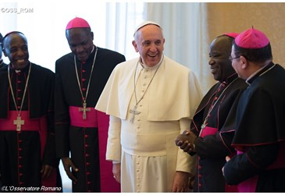
Pope Francis also warned against a breakdown of the family in Africa, and said the Church is called to evaluate and encourage every initiative to strengthen the family, “which is the real source of all forms of fraternity and the foundation and primary way of peace.”
The Holy Father also praised the work of missionaries and church personnel in helping the elderly and suffering on the continent, giving special mention to those who have given aid in the recent Ebola crisis in west Africa.
Pope Francis praised SECAM for attempting to provide “a common response to the new challenges facing the continent”, allowing the Church to “speak with one voice and to witness to her vocation as a sign and instrument of salvation, peace, dialogue and reconciliation.”
He said to fulfil this mission, it is important that SECAM remain faithful to its identity as “a vibrant experience of communion and of service to the poorest of the poor.”

ADDRESS OF HIS HOLINESS POPE FRANCIS TO REPRESENTATIVES OF THE SYMPOSIUM OF EPISCOPAL CONFERENCES OF AFRICA AND MADAGASCAR

Dear Brother Bishops,
I am pleased to meet with you, the representatives of the Symposium of Episcopal Conferences of Africa and Madagascar, and to encourage your work. SECAM was conceived and developed to be at the service of the local churches in Africa. It seeks to provide a common response to the new challenges facing the continent, allowing the Church to speak with one voice and to witness to her vocation as a sign and instrument of salvation, peace, dialogue and reconciliation. To fulfil this mission, it is important that SECAM remain faithful to its identity as a vibrant experience of communion and of service to the poorest of the poor.
To this end, pastors must remain free from worldly and political concerns, that they continually strengthen the bonds of fraternal communion with the Successor of Peter (through cooperation with the Apostolic Nunciatures), and through easy and direct communication with other Church bodies. At the same time, it is necessary to maintain the simple ecclesial experiences available to all, as well as streamlined pastoral structures. Experience teaches that large bureaucratic structures approach problems in the abstract and risk distancing the Church from people. For this reason, it is important to be concrete: that which is concrete is in touch with reality.
Above all, it is the youth who need your witness: young men and women look to us. In Africa, the future is in the hands of the young, who need to be protected from new and unscrupulous forms of “colonization” such as the pursuit of success, riches, and power at all costs, as well as fundamentalism and the distorted use of religion, in addition to new ideologies which destroy the identity of individuals and of families. The most effective way to overcome the temptation to give in to harmful lifestyles is by investing in education. Education will also help to overcome a widespread mentality of injustice and violence, as well as ethnic divisions. The greatest need is for a model of education which teaches the young to think critically and encourages growth in moral values (cf. Evangelii Gaudium, 64). An important component in this educational process is the pastoral care of students: in Catholic or public schools there is a need to unite academic studies with the explicit proclamation of the Gospel (cf. Evangelii Gaudium, 132-134).
There are various reasons why we are seeing, also in Africa, a trend towards the breakdown of the family. In response, the Church is called to evaluate and encourage every initiative to strengthen the family, which is the real source of all forms of fraternity and the foundation and primary way of peace (cf. John Paul II, Message for the XXVII World Day of Peace, 1 January 1994). More recently, many priests, men and women religious as well as members of the lay faithful have admirably taken responsibility for the care of families, with a special concern for the elderly, the sick and the handicapped. Even in the most distant and remote regions, your local Churches have proclaimed the Gospel of Life and, following the example of the Good Samaritan, have come to the help of those most in need. A magnificent witness to charity has been given in response to the recent outbreak of the Ebola virus, which has struck many communities, parishes and hospitals. Many African missionaries have generously given their lives by remaining close to those suffering from this disease. This path must be followed with renewed apostolic zeal! As followers of Christ, we cannot fail to be concerned for the welfare of the weakest; we must also draw the attention of society and the civil authorities to their plight.
Dear brothers, I express my appreciation for the invaluable contribution made by so many priests, men and women religious and lay faithful to the proclamation of the Gospel and the social advancement of your people. SECAM is also a means of promoting respect for the law, so as to ensure that the ills of corruption and fatalism may be healed, and to encourage the efforts of Christians in society as a whole, always in view of the common good. The great work of evangelization consists in striving to make the Gospel permeate every aspect of our lives so that we, in turn, can bring it to others. For this reason, it must always be borne in mind that evangelization implies conversion, that is, interior renewal. The process of purification, which is inherent in evangelization, means accepting the call of Christ to “repent and believe the Good News” (cf. Mk 1:15). As a result of this conversion to salvation, not only individuals but the entire ecclesial community is transformed, and becomes an ever greater and more vital expression of faith and of charity.
May the light and the strength of the Holy Spirit sustain your pastoral efforts. May the Virgin Mary protect you and intercede for you and for the entire continent of Africa. To each of you, I give my Apostolic Blessing. Please pray for me.
After the audience the Bishops presented a wood carving, depicting the Good Pastor, to Pope Francis.

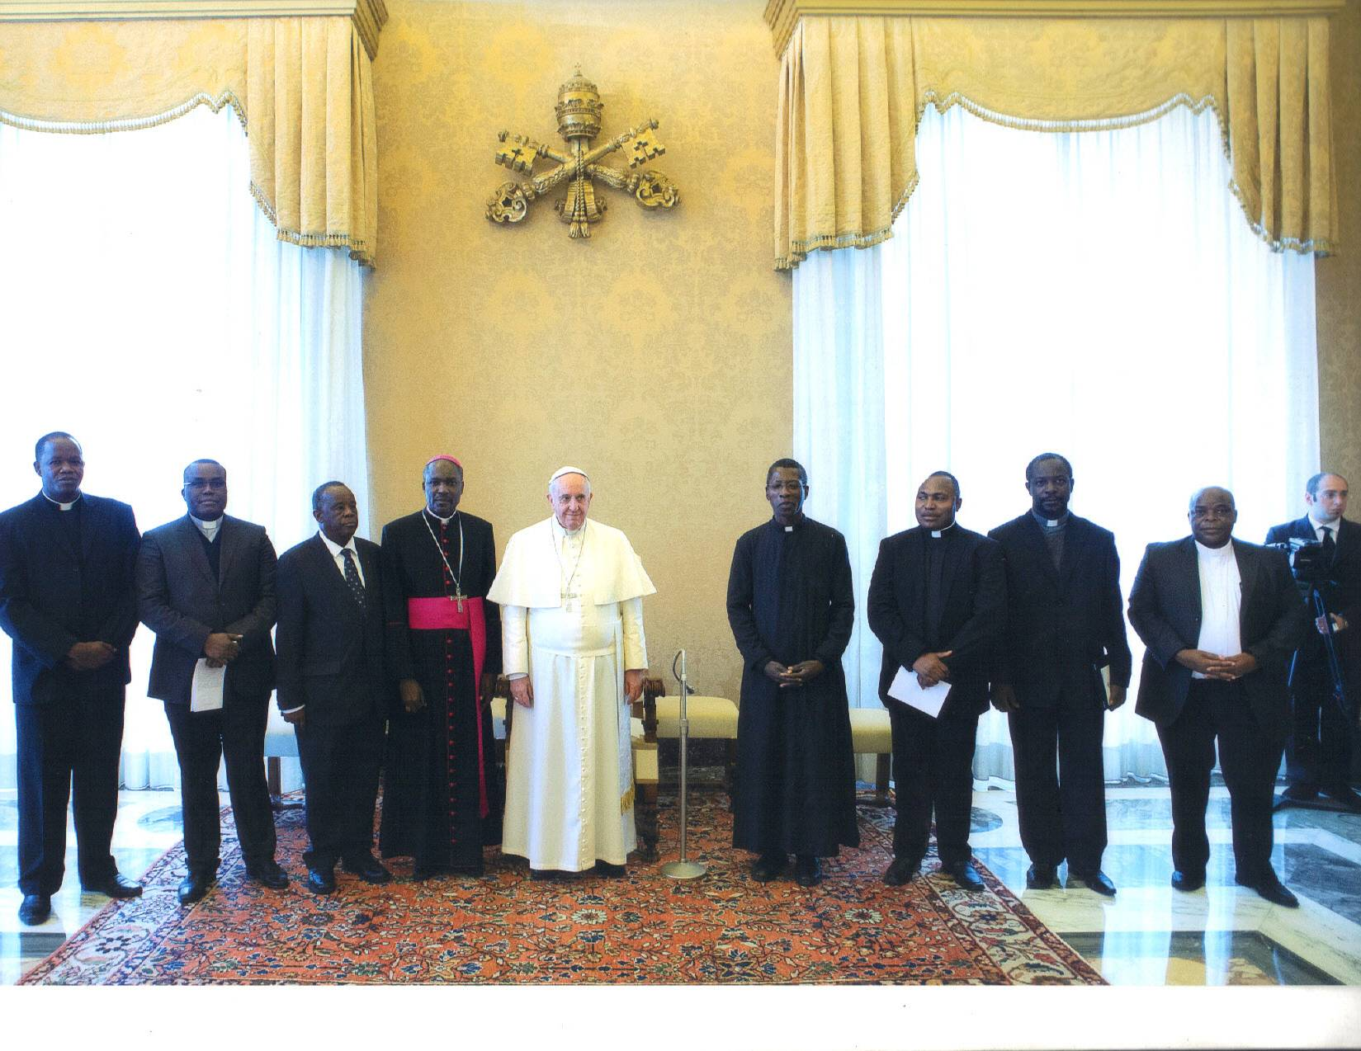

Pope Francis with the President of of SECAM and staff of SECAM Secretariat

.

- Secretary of State
After the audience with Pope Francis, the delegation met the Secretary of State, His Eminence Pietro Cardinal Parolin in his office at the Palazzo Apostolico. The President of SECAM expressed the appreciation and gratitude of SECAM to him for having made it possible for them to have met the Pope and the visits to the dicastries.
He also briefed the Secetary of State on the visits that the bishops made to the dicastries and that of the audience they had with the Holy Father just before meeting him( Cardinal Parolin).
Archbishop Mbilingi made a request for such visits to the Vatican after each Plenary Assembly of SECAM that is held every three years. ‘’ Such official visits by the new Office bearers of SECAM to the Holy Father and the various dicasteries we are convinced would strengthen the bond between SECAM and the Holy See and that of the e Universal Church.’’ He emphasised.
The President of SECAM informed him that in response to the call by Pope Benedict to SECAM, to hold a continental celebration (Africa) of the Year of Reconciliation (Africae Munus n° 155), in collaboration with the Holy See, this will start from 29th July, 2015 and climaxed with the Plenary Assembly of SECAM in July 2016 in Angola

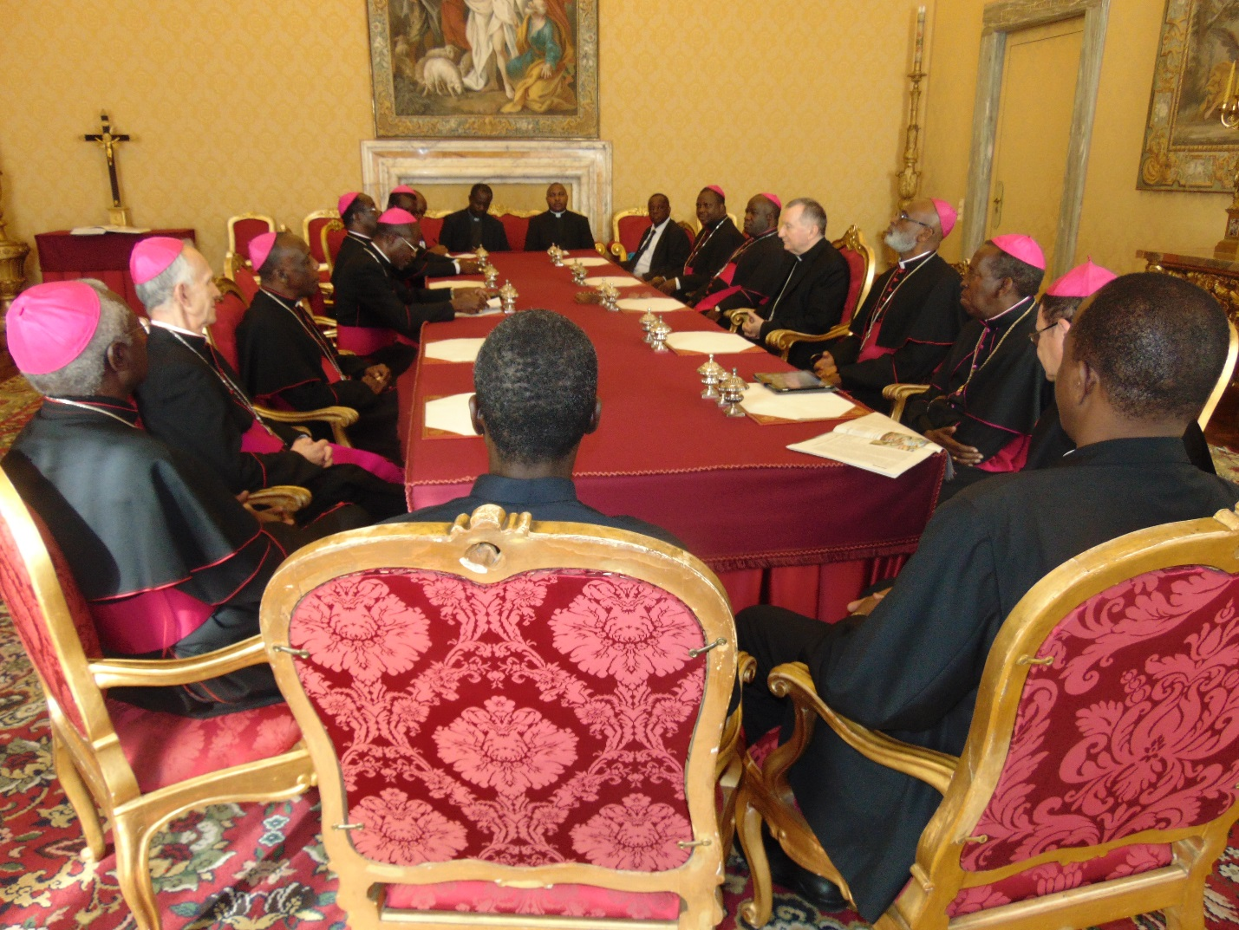
Cardinal Parolin with the SECAM delegation

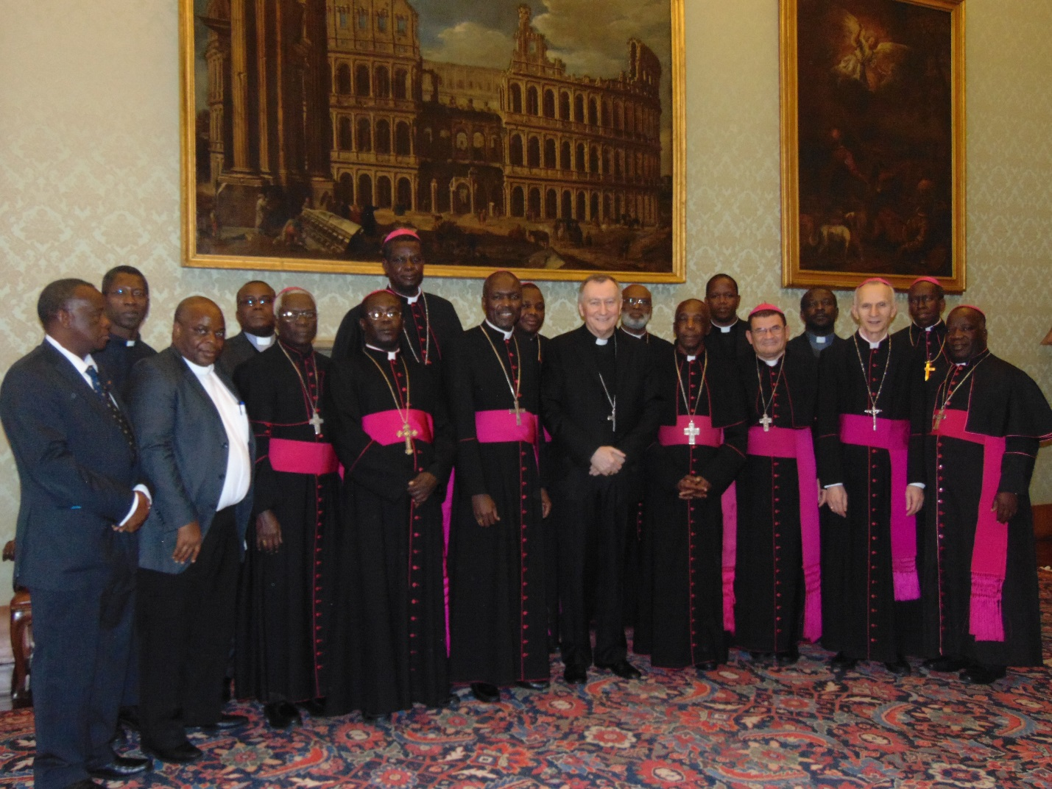
SECAM delegation with the Secretary of State, Cardinal Parolin at his office at the Vatican
Cardinal Parolin commended SECAM for making this first visit to the Vatican. He hoped that the discussions the delegation had with the various dicastries would go a long way to improve the working relations between SECAM and those offices (Dicastries).
He welcomed the suggestion of SECAM to have this kind of visit on regular basis. He promised to take up the matter with the Holy Father for the latters consideration.
- Pontifical Council for the Family
Due to an impromptu engagement of Archbishop Vincenzio Paglia, President of the Pontifical Council for the Family, the delegation could not meet him as scheduled on February 4. Archbishop Paglia however made it a point to meet the bishops. He did so briefly over a working Lunch on February 7 at Domus Romana Sacerdodtalis, Vatican.
The discussions centred mainly on issues relating to the Family with particular reference to the two Synods on the Family; that of October 2014 and the forthcoming one in October 2015.
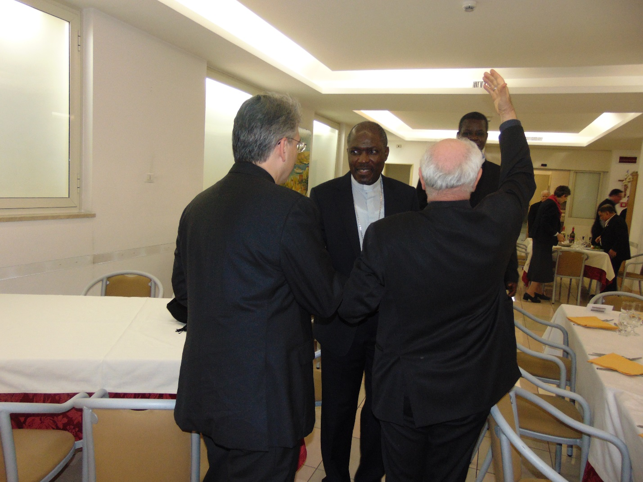
Archbishop Paglia back to camera with hand raised talking to Archbishops Mbilingi & Kleda. With them is Mons. Riccardo Mensuali, Secretary of the President of Pontifical Council for the Family.

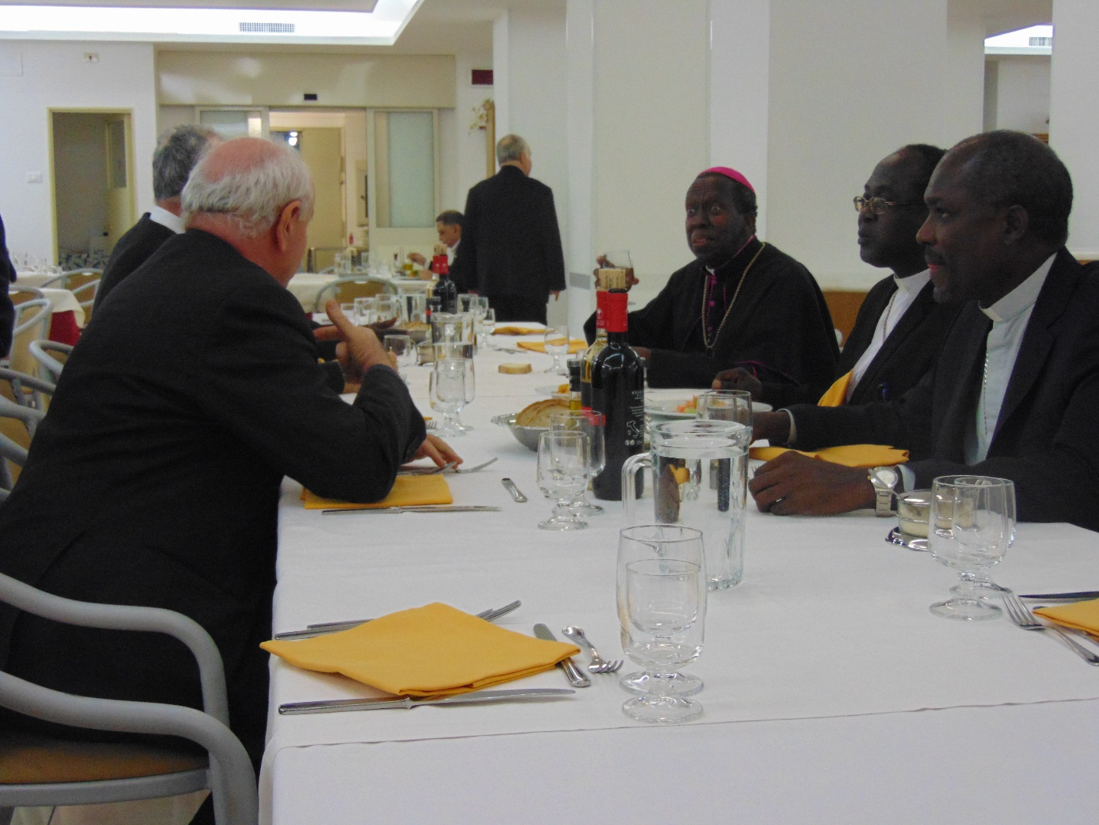
Archbishop Paglia at Lunch with some of the Bishops.
- Mass at the Tomb of St. Peter
On the last day of the visit, the delegation celebrated the Eucharist at the tomb of St. Peter at St Peter’s Basilica.
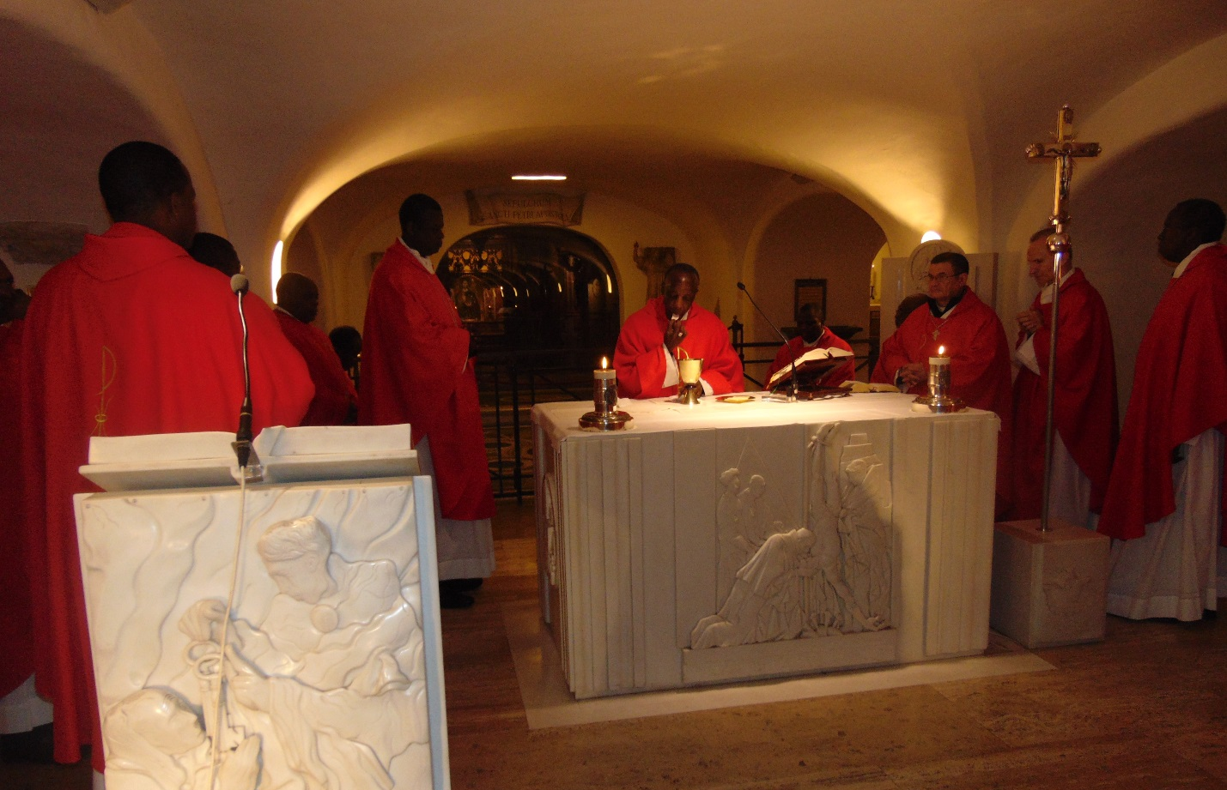
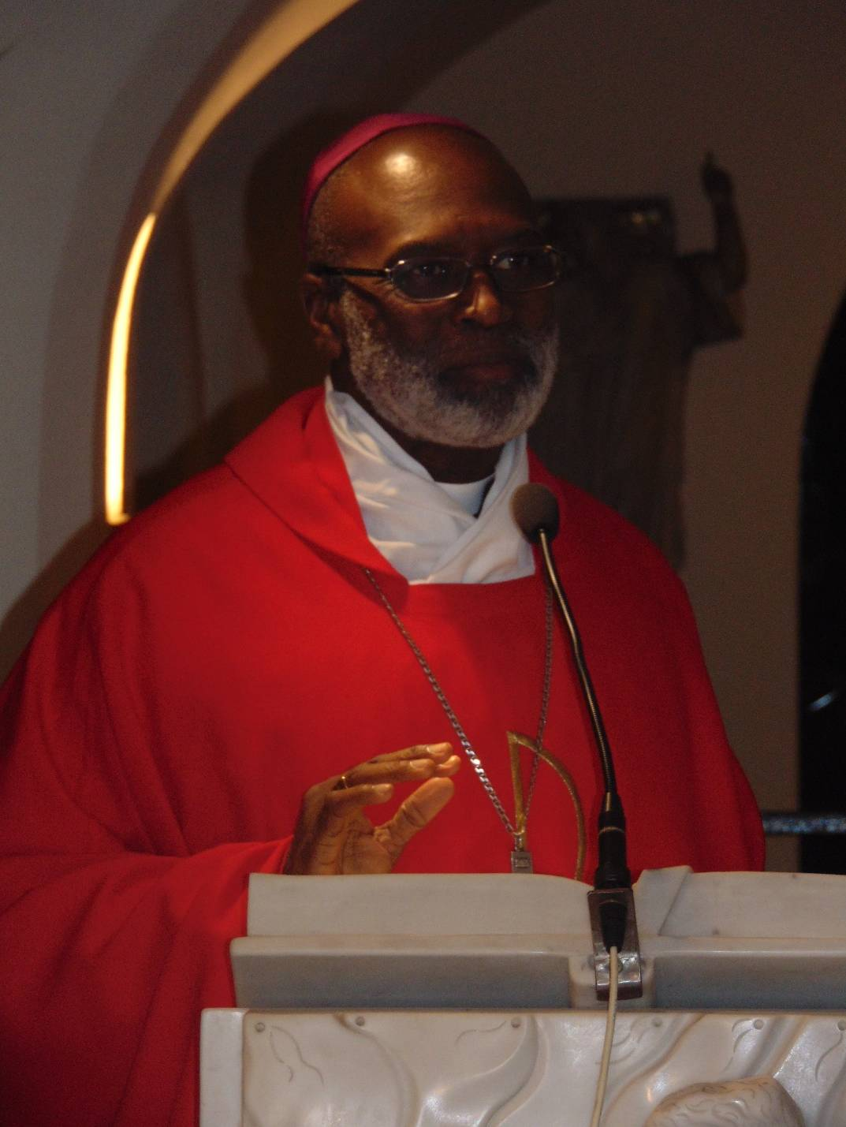
The main celebrant, Archbishop Palmer-Buckle delivery a homily.
11.Press Conference at Vatican Radio
On the last day of the visit, the Standing Committee held a Press Conference in the Conference Hall of Vatican Radio. It was attended mainly by African journalists who are working at Vatican Radio,( French, English and Portuguese Sections).

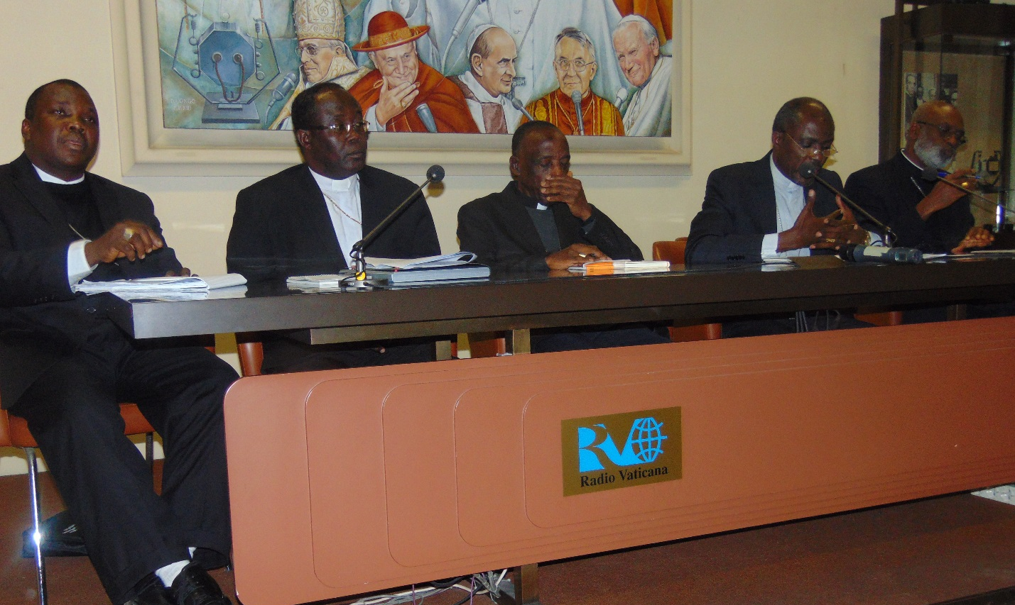
Aaddressing a Press Conference at Vatican Radio (left to right) Bishop E. Badejo, Archb. G. Anokye, Bishop Portella-Mbuyu, Archbishops Mbilingi and Palmer-Buckle.
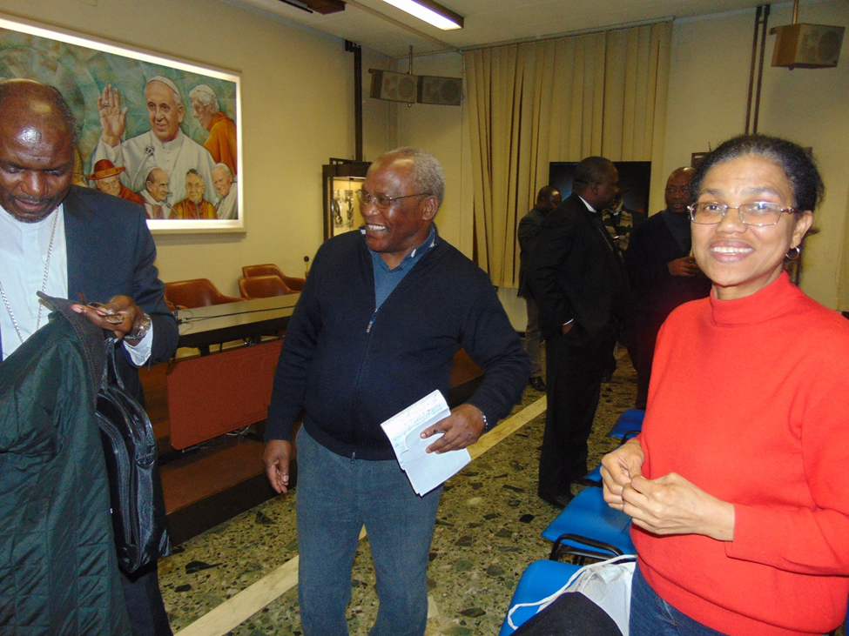
Archbishop Mbilingi having a chat with journalists ( Fr. B. Suarte and Madam Dulce ) of the Portuguese Africa Section of Radio Vatican.
- Introduction of the Chairman of CEPACS to the President of the PCSC.
In another development, Most Rev. Dr. Emmanuel Adetoyese Badejo, Bishop of Oyo diocese, Nigeria,who was recenty appointed the Chairman for Communications of SECAM was officially introduced to the President of the Pontifical Council for Social Communications (PCSC), Archbishop Claudio Maria Celli. The President of SECAM, Archbishop Gabriel Mbilingi of Lubango, Angola introduced him to the Council on February 6, 2015 during the SECAM visit to the Vatican.
The appointment of Bishop Badejo is seen as an attempt to revive the Pan-African Episcopal Committee for Social Communications, which has the acronym CEPACS, derived from the original French name: Comité Episcopal Pan-Africain des Communications Sociales. CEPACS which has been without a Chairman since 2004 was established in Ibadan, Nigeria, at the end of a meeting that took place from November, 28 to December 2, 1973 of African bishops in collaboration with the Pontifical Council for Social Communications and Stem Van Afrika (Voice of Africa) in The Netherlands.
Bishop. Badejo, who is already Chairman of Social Communications Directorate of the Catholic Bishops Conference of Nigeria (CBCN), will be the fifth Chairman for SECAM Communications. He was born on July 13, 1961.
He had his secondary education in the Local Church Minor Seminary, he studied philosophy at the Regional Major Seminary of Ss. Peter and Paul which was affiliated to Nigeria’s premier university, the University of Ibadan, until 1980. He then went to Rome, Italy to undertake theological studies.
In the summer of 1983 he pursued a Bible Course at the Hebrew University in Hadassah, Jerusalem. In 1984, he graduated with a Bachelor of Theology degree from the Pontifical Urban University in Rome. Bishop Badejo was ordained a priest in Osogbo, Nigeria, on January 4, 1986, where he served as an Associate Pastor for seven years. During that period he held many positions, for example: Diocesan Vocations Director, Assistant Diocesan Communications Director and Chairman, Diocesan Communications Director.
Bishop Badejo is also a musician, loves drama and has produced a number of video programmes:
He is also a Columnist for some Nigerian national newspapers, regular guest on many audio visual programmes and a well-known preacher and speaker.
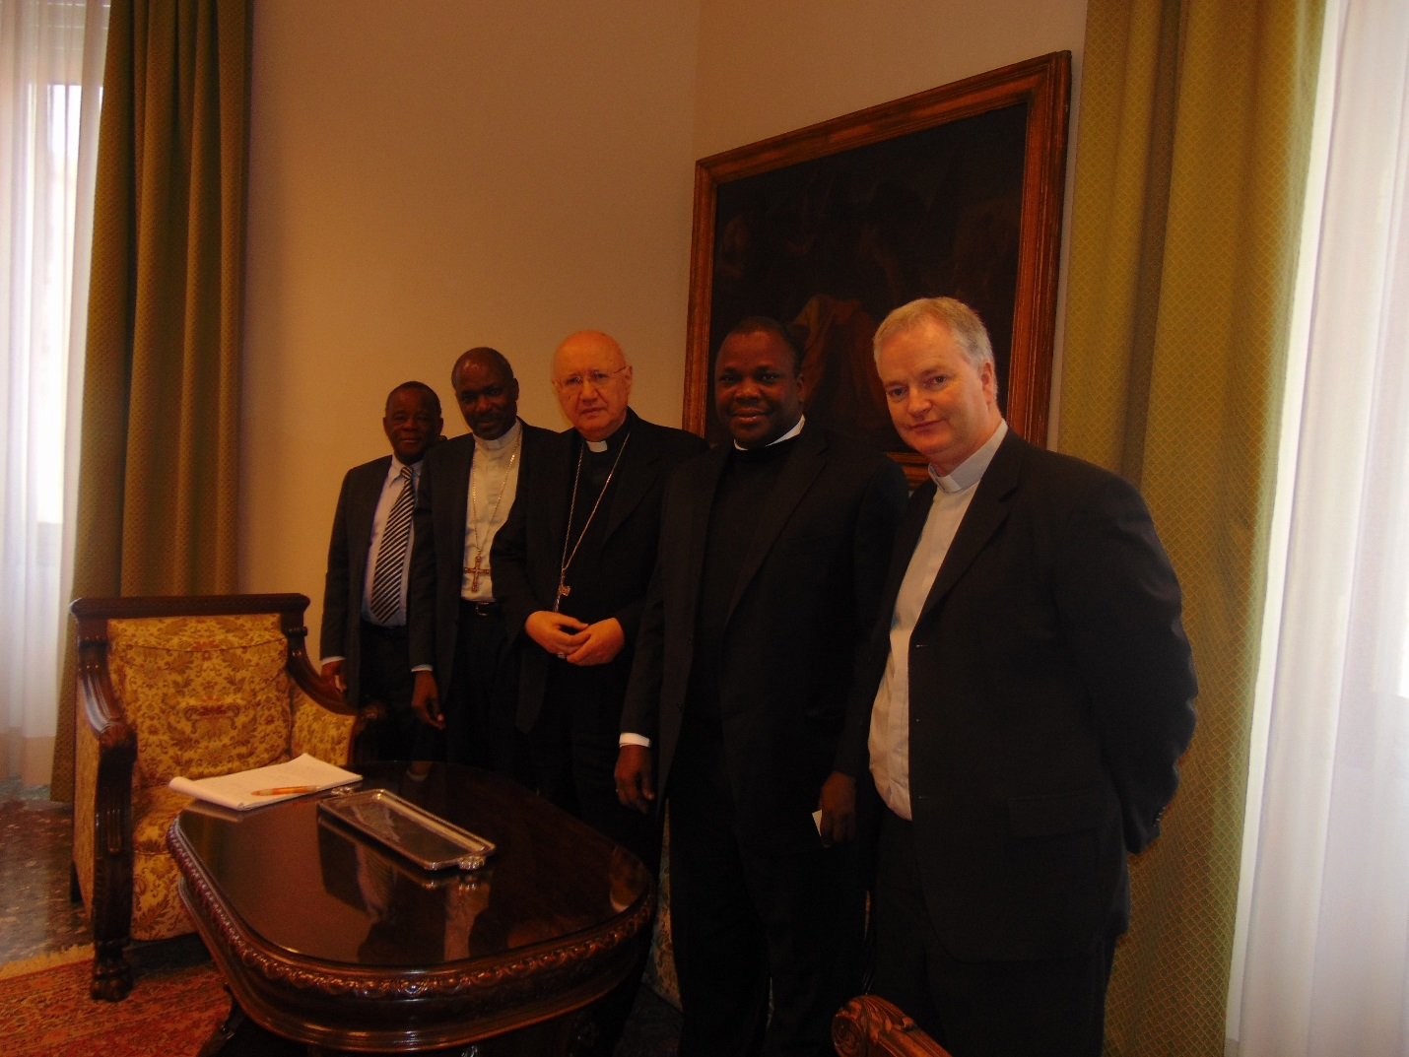

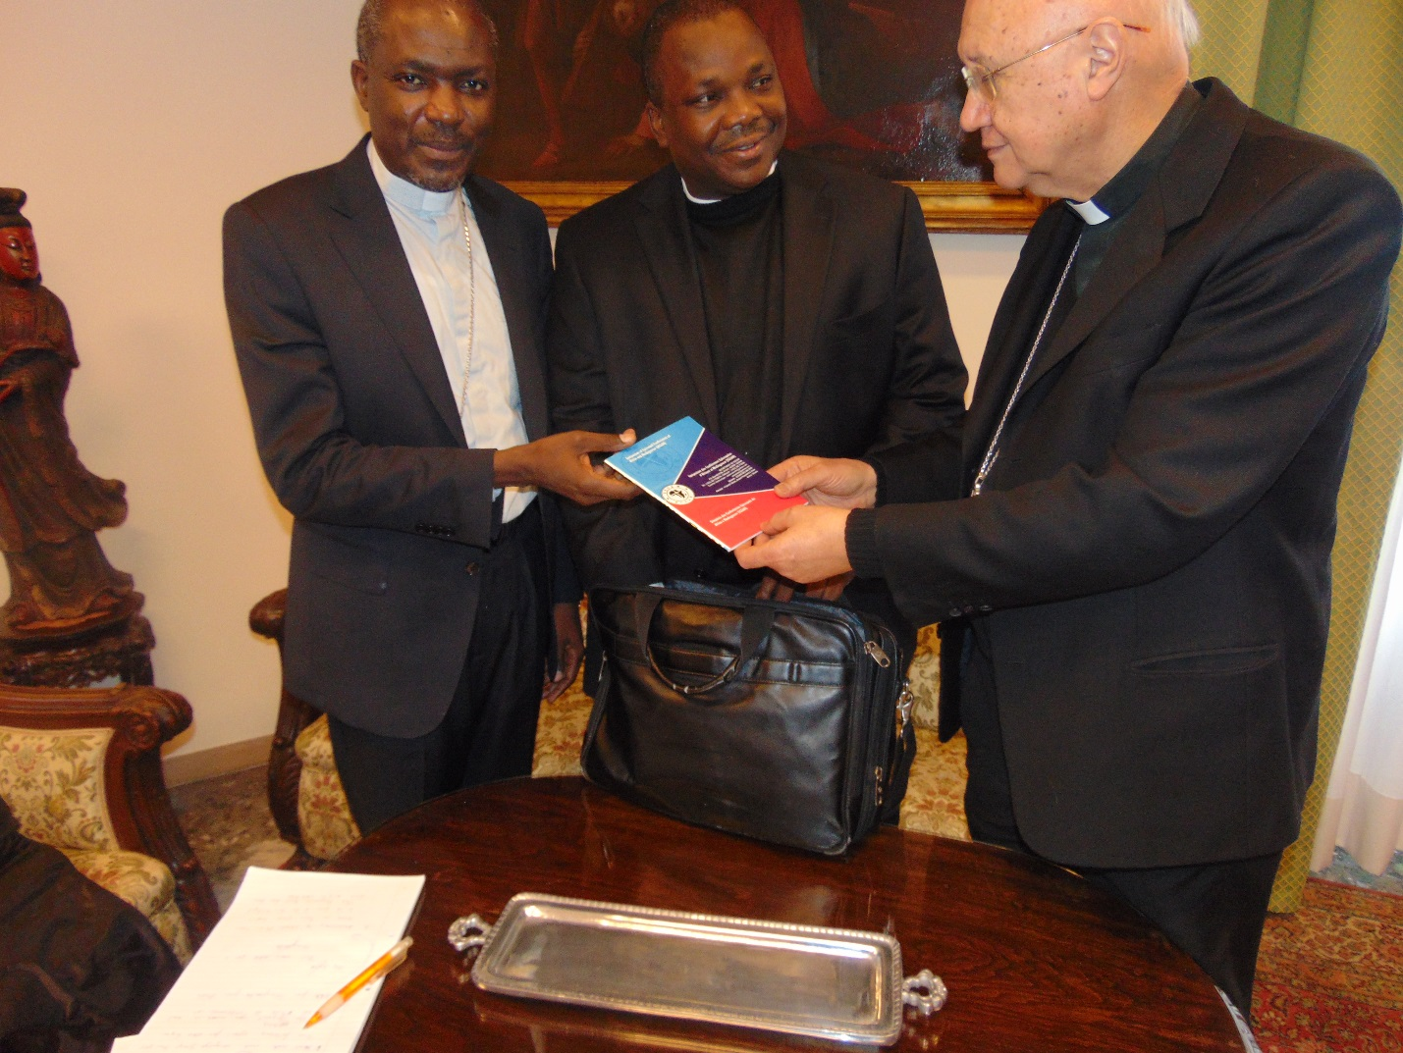
Archbishop Celli receiving some publications of SECAM from Archbishop Mbiling. Looking on is Bishop Badejo

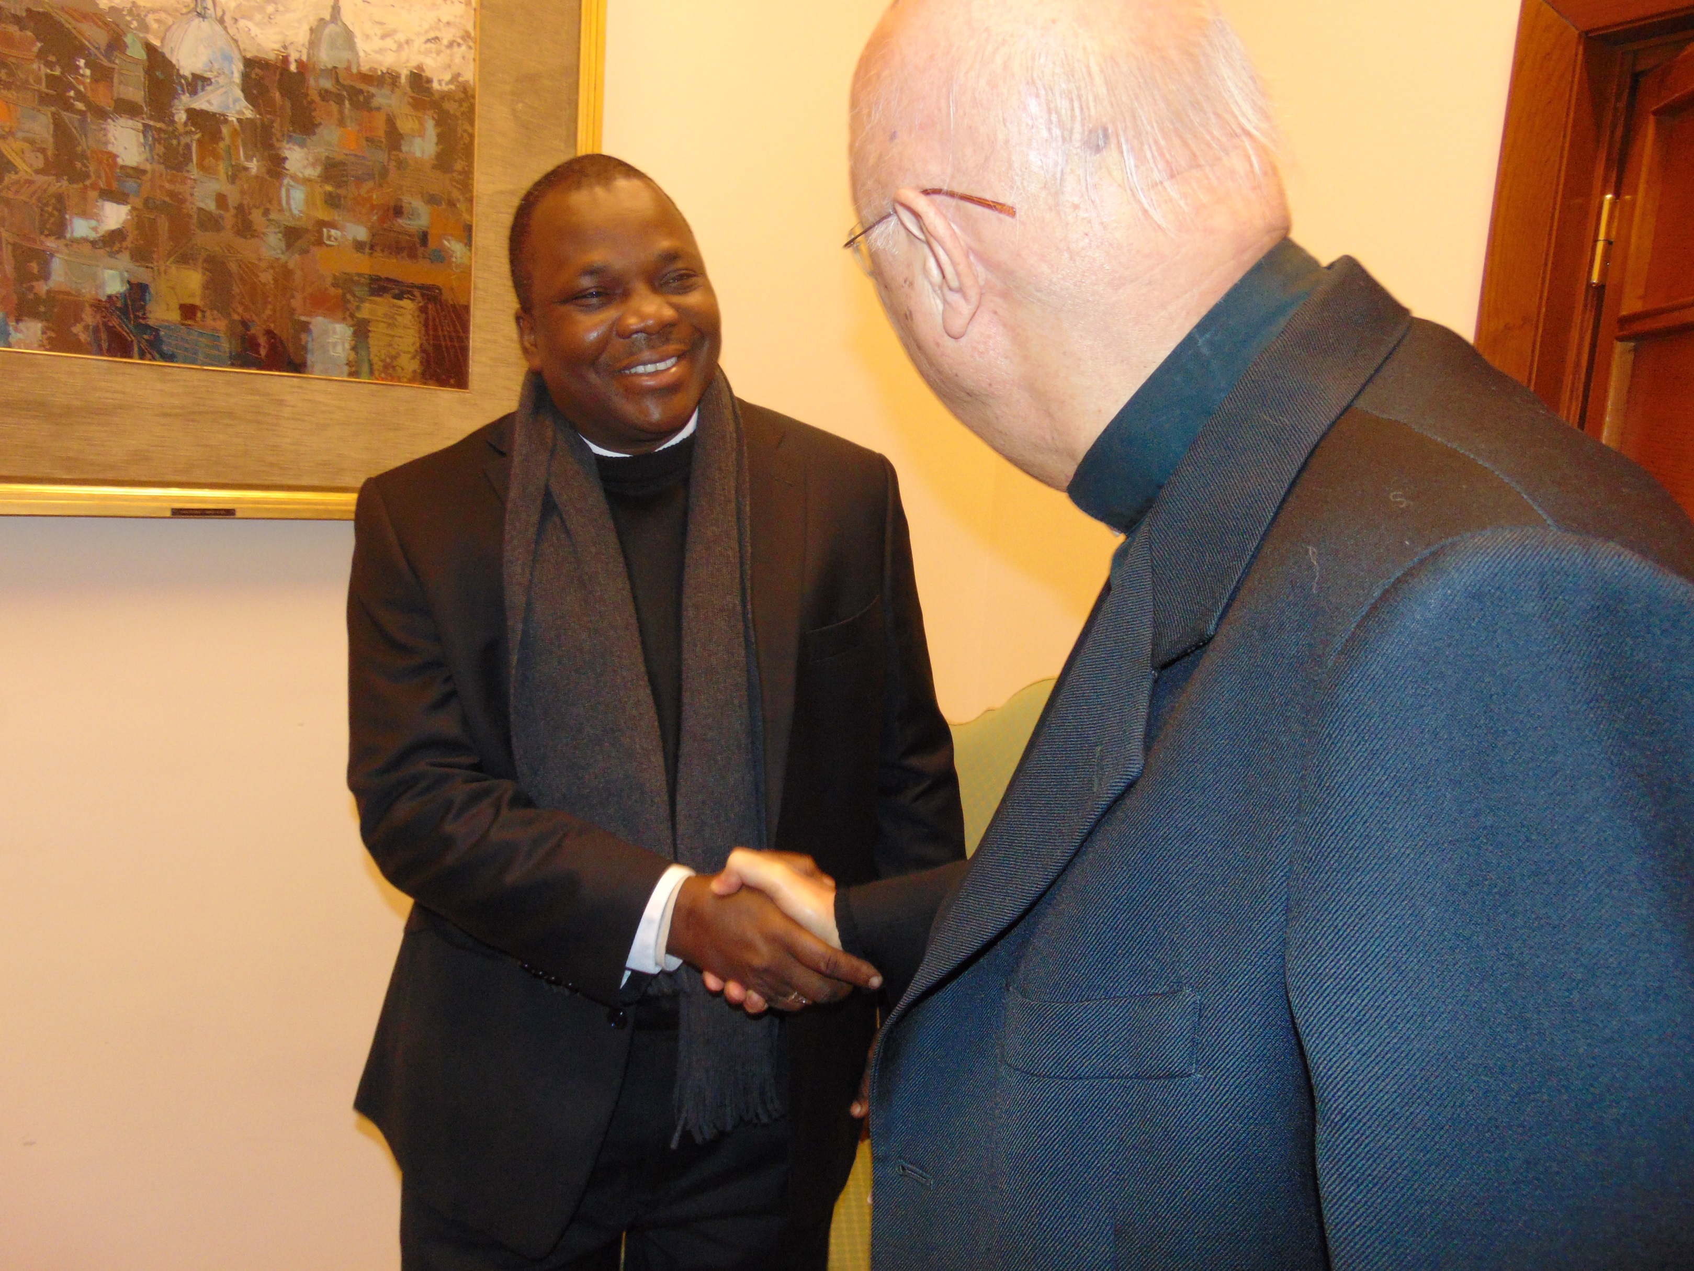
Bishop Badejo being congratualted by Archbishop Celli on his appointment as Chairman of SECAM Communications/CEPACS.
Services Rendered by Operal Della Chiesa ( The Work of the Church)
During the pilgrimage Opera della Chiesa rendered invaluable services, for example, by providing the transportation needs of the delegation of SECAM during their wehole stay in Rome. The delegation was also hosted to a dinner at the Residence of the Opera della Chiesa; this was preceded by an Eucharitic celebration. The delegation viewed a documentary of the Founder of their Founder, Mother Trinidad de la Santa Madre Iglesia. She founded Opera della Chiesa in 1959 “in which bishops, priest, men and women consecrated to God, married people, youths and children become part of it with the only purpose of helping the Pope and bishops present the true face of the Church.”

Compiled by: Benedict Assorow, Director of Communications, SECAM.

